**Project Report**

**On**

**E-Commerce Website**

Submitted as **MAJOR PROJECT** for Partial fulfilment of the requirement for the award

Of

# **BACHELOR OF COMPUTER APPLICATION**

Session 2021-2024



# **INSTITUTE OF MANAGEMENT EDUCATION**

(Affiliated to Chaudhary Charan Singh University, Meerut)

**Submitted to** – **Submitted by** - Honey Kumar Sir. Parth Srivastava

BCA-6th Semester

Roll No. 210938106124

# Certificate

I hereby certify that Parth Srivastava (RollNo.

210938106124) a Student of BACHELORE OF COMPUTER APPLICATION (2021-2024) has successfully completed the E-Commerce Website project under my supervision. Throughout this endeavor, He displayed commendable skills in website development, ensuring a seamless user experience.

Honey Kumar Sir

# Declaration

This Major Project Report on “E-commerce Website” has been undertaken as a partial fulfilment of the requirement for the award of the degree of Bachelor Of Computer Application from Chaudhary Charan Singh University, Meerut.

I hereby declare that this Research Project is my original work and the analysis and findings are for academic purpose only.

Parth Srivastava

RollNo-210938106124

# Acknowledgement

I would like to express my sincere gratitude to Honey Kumar Sir, for their invaluable guidance and support throughout the development of this E-commerce website project.

Their expertise and encouragement played a pivotal role in shaping the project. I extend my appreciation to my peers and mentors who provided valuable insights and constructive feedback. Special thanks to my family and friends for their unwavering support. This project wouldn't have been possible without the collective effort and encouragement from everyone involved.

Honey Kumar Sir

Abstract

Skull is a robust e-commerce website tailored specifically for men's clothing, providing a seamless shopping experience coupled with convenient user registration functionalities. This project endeavors to create an engaging online platform where customers can browse through a diverse range of clothing options and make purchases with ease.

The primary focus of Skull is to offer a curated collection of men's apparel, catering to various styles, preferences, and occasions. Through an intuitive and visually appealing interface, users can explore different categories, filter options, and view detailed product descriptions, enabling informed purchasing decisions.

One of the distinguishing features of Skull is its user registration system, which allows customers to create accounts and securely store their personal information in the backend database.

In conclusion, Skull represents a comprehensive solution for men seeking quality clothing options online, combining a diverse product range with user-friendly features like registration to elevate the shopping experience. Through continuous refinement and innovation, Skull strives to emerge as a prominent player in the ever-evolving realm of e-commerce.

# INDEX

|  |  |  |
| --- | --- | --- |
| S.No | Conclusion | Page.No |
| 1 | Certificate | 2 |
| 2 | Declaration | 3 |
| 3 | Acknowledgement | 4 |
| 4 | Abstract | 5 |
| 5 | Web Development | 8 - 10 |
| 6 | Steps to create a website | 11 |
| 7 | HTML | 12 - 14 |
| 8 | CSS | 15 - 17 |
| 9 | JavaScript | 18 |
| 10 | php | 19 |
| 11 | MySql | 20 |
| 12 | XAMPP | 21 |
| 13 | What is E-commerce Website | 22 - 23 |
| 14 | Html Code | 24 - 74 |
| 15 | CSS Code | 75 - 101 |
| 16 | JavaScript Code | 102 |
| 17 | php Code | 103 |
| 18 | XAMPP- PhpMyAdmin | 104 |
| 19 | Screenshot of Website | 105 - 123 |
| 20 | Conclusion | 124 |
| 21 | Bibliography | 125 |

# Web Developement

Web development is the process of building and maintaining websites or web applications. It encompasses a range of tasks and skills that contribute to the creation of a functional and visually appealing online presence. Web development involves both front-end and back-end development, as well as other crucial elements that ensure a seamless and interactive user experience.

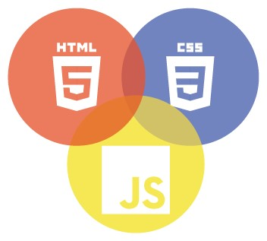

What is Web-Site:

A website is a collection of web pages, typically related to one another and hosted on a web server. These pages are usually accessible through a common domain name and can contain various types of content, such as text, images, videos, and interactive elements like forms or games. Websites are accessed using web browsers like Chrome, Firefox, or Safari, and they serve a wide range of purposes, from providing information and entertainment to facilitating communication and commerce.

What is Web-Page:

A webpage is a single document or resource that is part of a website. It is typically written in HTML (Hypertext Markup Language) and may also include other technologies such as CSS (Cascading Style Sheets) for styling and JavaScript for interactivity. Webpages can contain various types of content, including text, images, videos, links, forms, and more. When you visit a website, your web browser loads and displays its individual webpages, allowing you to navigate between them by clicking on links or using other navigation elements.

Steps To Create a Web-Site

  

Languages and Technologies Used in This Project:

* HTML
* CSS
* JavaScript
* PHP
* MySql
* XAMPP

# HTML

HTML, or Hypertext Markup Language, serves as the foundational language for creating and structuring content on the World Wide Web. Developed by Sir Tim Berners-Lee in 1991, HTML has undergone several iterations, with HTML5 being the latest standard as of my knowledge cutoff in January 2022. This markup language provides a standardized way to describe the structure of web documents, allowing browsers to render them consistently across various platforms.



At its core, HTML employs a system of tags and attributes to define the elements within a document. Tags are enclosed in angle brackets and typically come in pairs—a start tag and an end tag—surrounding the content they affect. For example, the `<p>` tag denotes a paragraph, and `</p>` signals the end of that paragraph. This structured approach enables web developers to organize and present information in a logical and hierarchical manner.

HTML documents have a standard structure that includes essential sections. The `<!DOCTYPE html>` declaration at the beginning informs the browser about the HTML version in use. The `<html>` element encloses the entire document, while the `<head>` section contains meta-information, such as the document title displayed in the browser tab. The `<body>` section houses the main content of the web page.

HTML5 introduced semantic elements, offering a more meaningful way to describe document structure. Semantic tags like `<header>`, `<nav>`, `<article>`,

`<section>`, and `<footer>` enhance the clarity of content and facilitate better accessibility and search engine optimization. These elements contribute to a more robust and semantically rich representation of information on the web.

HTML is an integral part of the broader web development stack, working in conjunction with Cascading Style Sheets (CSS) for styling and layout, and JavaScript for dynamic behavior and interactivity. This trio of technologies, often referred to as HTML, CSS, and JS (or the "frontend stack"), empowers developers to create visually appealing, responsive, and interactive websites.

As the internet landscape evolves, HTML continues to adapt. Its "living standard" status means ongoing development and refinement to meet the demands of modern web development. Whether for simple static pages or complex web applications, HTML remains the cornerstone of web content creation, providing the structure necessary for delivering information across the vast expanse of the World Wide Web.

# **CSS**

CSS, or Cascading Style Sheets, is a crucial web technology that complements HTML by providing a means to control the presentation and layout of web documents. Developed in the late 1990s, CSS allows web developers to separate the structure and content of a webpage from its visual design, fostering cleaner, more maintainable code and enabling consistent styling across multiple pages.

At its core, CSS operates through a set of rules that define how HTML elements should be displayed. These rules consist of selectors, properties, and values. Selectors target specific HTML elements, and the associated properties and values dictate the desired appearance.

Selectors can be more specific, targeting elements

based on their class, ID, or hierarchical relationships. This flexibility allows for precise styling of individual elements or groups of elements.

CSS employs a cascade mechanism, meaning that multiple style rules can apply to the same element. The rules are prioritized based on specificity, importance, and source order. This allows developers to create a consistent and coherent visual design while accommodating variations and overrides when necessary.

One of the strengths of CSS is its ability to control layout and positioning. Flexbox and Grid, introduced in CSS3, are layout models that enable developers to create complex, responsive designs with relative ease. Flexbox excels at building one-dimensional layouts, while Grid is well-suited for two-dimensional layouts, offering a grid-based structure.

Responsive web design, a crucial aspect of modern web development, is achieved through CSS media queries. These queries allow developers to apply different styles based on factors like screen size, resolution, or device orientation. This ensures a seamless user experience across a diverse range of devices, from desktop monitors to smartphones and tablets.

CSS preprocessors, such as Sass and Less, extend the capabilities of traditional CSS by introducing features like variables, nesting, and mixins. These tools enhance code maintainability and allow developers to write more efficient and modular stylesheets.

JavaScript

JavaScript is a scripting or programming language that allows you to implement complex features on web pages — every time a web page does more than just sit there and display static information for you to look at — displaying timely content updates, interactive maps, animated 2D/3D graphics, scrolling video jukeboxes, etc. — you can bet that JavaScript is probably involved. It is the third layer of the layer cake of standard web technologies, two of which (HTML and CSS) we have covered in much more detail in other parts of the Learning Area.

PHP

The term PHP is an acronym for – Hypertext Preprocessor. PHP is a server-side scripting language designed specifically for web development. It is open-source which means it is free to download and use. It is very simple to learn and use. The file extension of PHP is “.php”.



PHP was introduced by Rasmus Lerdorf in the first version and participated in the later versions. It is an interpreted language and it does not require a compiler.

PHP can actually do anything related to server-side scripting or more popularly known as the backend of a website. For example, PHP can receive data from forms, generate dynamic page content, can work with databases, create sessions, send and receive cookies, send emails, etc. There are also many hash functions available in PHP to encrypt users’ data which makes PHP secure and reliable to be used as a server-side scripting language. So these are some of PHP’s abilities that make it suitable to be used as a server-side scripting language.

MySql

MySQL, the most popular Open Source SQL database management system, is developed, distributed, and supported by Oracle Corporation.

A database is a structured collection of data. It may be anything from a simple shopping list to a picture gallery or the vast amounts of information in a corporate network. To add, access, and process data stored in a computer database, you need a database management system such as MySQL Server. Since computers are very good at handling large amounts of data, database management systems play a central role in computing, as standalone utilities, or as parts of other applications.

The SQL part of “MySQL” stands for “Structured Query Language”. SQL is the most common standardized language used to access databases. Depending on your programming environment, you might enter SQL directly (for example, to generate reports), embed SQL statements into code written in another language, or use a language-specific API that hides the SQL syntax.

# XAMPP

XAMPP is one of the widely used cross-platform web servers, which helps developers to create and test their programs on a local webserver. It was developed by the **Apache Friends**, and its native source code can be revised or modified by the audience. It consists of **Apache HTTP Server, MariaDB, and interpreter** for the different programming languages like PHP and Perl. It is available in 11 languages and supported by different platforms such as the IA-32 package of Windows & x64 package of macOS and Linux.



XAMPP is an abbreviation where X stands for Cross-Platform, A stands for Apache, M stands for [MYSQL](https://www.javatpoint.com/mysql-tutorial), and the Ps stand for PHP and Perl*,* respectively. It is an open-source package of web solutions that includes Apache distribution for many servers and command-line executables along with modules such as Apache server, [MariaDB](https://www.javatpoint.com/mariadb-tutorial), PHP, and Perl.

What is E-Commerce Website

An e-commerce website is an online platform that facilitates buying and selling of goods or services over the internet. It serves as a virtual marketplace where businesses and consumers can interact, browse through products or services, make purchases, and conduct transactions electronically. E-commerce websites typically feature various functionalities such as product listings, shopping carts, secure payment gateways, and order processing systems.

These websites allow businesses to reach a global audience without the limitations of physical storefronts, enabling them to expand their market reach and increase sales potential. Similarly, consumers benefit from the convenience of shopping from anywhere at any time, accessing a wide range of products and services with just a few clicks.

E-commerce websites come in different forms, including business-toconsumer (B2C), business-to-business (B2B), consumer-to-consumer (C2C), and consumer-to-business (C2B) models. Each model caters to specific types of transactions and target audiences.

Key features of e-commerce websites often include:

* Product catalog: Display of products or services with detailed descriptions, images, and pricing information.
* Shopping cart: Functionality that allows users to add items they wish to purchase and review them before checkout.
* Secure payment gateways: Integration of secure payment methods to facilitate safe and convenient transactions.
* User accounts: Registration and login options for users to create accounts, manage orders, and track shipments.
* Search and filtering: Tools to help users easily find specific products or services within the website.
* Order management: Systems to process and fulfill orders efficiently, including inventory management and shipping logistics.

Overall, e-commerce websites play a crucial role in modern commerce, revolutionizing the way businesses and consumers engage in buying and selling transactions, making commerce more accessible, efficient, and scalable.

HTML Code

Index.html

<!DOCTYPE html>

<html lang="en">

<head>

    <meta charset="UTF-8">

    <meta http-equiv="X-UA-Compatible" content="IE=edge">

    <meta name="viewport" content="width=device-width, initial-scale=1.0">

    <title>Document</title>

    <link rel="stylesheet" href="https://cdnjs.cloudflare.com/ajax/libs/font-awesome/6.4.2/css/all.min.css" />

    <link rel="stylesheet" href="style.css">

</head>

<body>

    <section id="header">

        <a href="#"><img src="img/logo.png" class="logo" alt=""></a>

        <div>

            <ul id="navbar">

                <li><a class="active" href="index.html">Home</a></1i>

                <li><a href="shop.html">Shop</a></1i>

                <li><a href="blog.html">Blog</a></1i>

                <li><a href="about.html">About</a></1i>

                <li><a href="contact.html">Contact</a></1i>

                <li><a href="sign.html">Sign-Up</a></1i>

                <li id="lg-bag"><a href="cart.html"><i class="fa-solid fa-bag-shopping"></i></a></1i>

                <li><a href="#" id="close"><i class="fa-solid fa-xmark"></i></a></li>

            </ul>

        </div>

        <div id="mobile">

            <a href="cart.html"><i class="fa-solid fa-bag-shopping"></i></a>

            <i id="bar" class="fa-solid fa-bars"></i>

        </div>

    </section>

    <section id="hero">

        <h4>Trade-in-offer</h4>

        <h2>Super Value deals</h2>

        <h1>ON all products</h1>

        <p>save more with coupons & up to 60% off!</p>

        <button>Shop Now</button>

    </section>

    <section id="feature" class="section-p1">

        <div class="fe-box">

            <img src="img/features/f1.png" alt="">

            <h6>free shipping</h6>

        </div>

        <div class="fe-box">

            <img src="img/features/f2.png" alt="">

            <h6>Online Order</h6>

        </div>

        <div class="fe-box">

            <img src="img/features/f3.png" alt="">

            <h6>Save Money</h6>

        </div>

        <div class="fe-box">

            <img src="img/features/f4.png" alt="">

            <h6>Promotions</h6>

        </div>

        <div class="fe-box">

            <img src="img/features/f5.png" alt="">

            <h6>Happy Sell</h6>

        </div>

        </div>

        <div class="fe-box">

            <img src="img/features/f6.png" alt="">

            <h6>24/7 Support</h6>

        </div>

    </section>

    <section id="product1" class="section-p1">

        <h2>Featured Products</h2>

        <p>Summer Collection New Mordern Design</p>

        <div class="pro-container">

            <div class="pro" onclick="window.location.href='sproduct.html'">

                <img src="img/products/f1.jpg" alt="">

                <div class="des">

                    <span>adidas</span>

                    <h5>Naruto: Team Seven</h5>

                    <div class="star">

                        <i class="fas fa-star"></i>

                        <i class="fas fa-star"></i>

                        <i class="fas fa-star"></i>

                        <i class="fas fa-star"></i>

                        <i class="fas fa-star"></i>

                    </div>

                    <h4>$78</h4>

                </div>

                <a href="#"><i class="fa-solid fa-cart-shopping cart"></i></a>

            </div>

            <div class="pro" onclick="window.location.href='sproduct.html'">

                <img src="img/products/f2.jpg" alt="">

                <div class="des">

                    <span>adidas</span>

                    <h5>Star Wars: Do or Do Not</h5>

                    <div class="star">

                        <i class="fas fa-star"></i>

                        <i class="fas fa-star"></i>

                        <i class="fas fa-star"></i>

                        <i class="fas fa-star"></i>

                        <i class="fas fa-star"></i>

                    </div>

                    <h4>$78</h4>

                </div>

                <a href="#"><i class="fa-solid fa-cart-shopping cart"></i></a>

            </div>

            <div class="pro" onclick="window.location.href='sproduct.html'">

                <img src="img/products/f3.jpg" alt="">

                <div class="des">

                    <span>adidas</span>

                    <h5>Joker: Wanted!</h5>

                    <div class="star">

                        <i class="fas fa-star"></i>

                        <i class="fas fa-star"></i>

                        <i class="fas fa-star"></i>

                        <i class="fas fa-star"></i>

                        <i class="fas fa-star"></i>

                    </div>

                    <h4>$78</h4>

                </div>

                <a href="#"><i class="fa-solid fa-cart-shopping cart"></i></a>

            </div>

            <div class="pro" onclick="window.location.href='sproduct.html'">

                <img src="img/products/f4.jpg" alt="">

                <div class="des">

                    <span>adidas</span>

                    <h5>Black Panther: This is Wakanda</h5>

                    <div class="star">

                        <i class="fas fa-star"></i>

                        <i class="fas fa-star"></i>

                        <i class="fas fa-star"></i>

                        <i class="fas fa-star"></i>

                        <i class="fas fa-star"></i>

                    </div>

                    <h4>$78</h4>

                </div>

                <a href="#"><i class="fa-solid fa-cart-shopping cart"></i></a>

            </div>

            <div class="pro" onclick="window.location.href='sproduct2.html'">

                <img src="img/products/f5.jpg" alt="">

                <div class="des">

                    <span>adidas</span>

                    <h5>Spider-Man: The Web Slinger</h5>

                    <div class="star">

                        <i class="fas fa-star"></i>

                        <i class="fas fa-star"></i>

                        <i class="fas fa-star"></i>

                        <i class="fas fa-star"></i>

                        <i class="fas fa-star"></i>

                    </div>

                    <h4>$78</h4>

                </div>

                <a href="#"><i class="fa-solid fa-cart-shopping cart"></i></a>

            </div>

            <div class="pro" onclick="window.location.href='sproduct2.html'">

                <img src="img/products/f6.jpg" alt="">

                <div class="des">

                    <span>adidas</span>

                    <h5>Donald Duck: Problem Child</h5>

                    <div class="star">

                        <i class="fas fa-star"></i>

                        <i class="fas fa-star"></i>

                        <i class="fas fa-star"></i>

                        <i class="fas fa-star"></i>

                        <i class="fas fa-star"></i>

                    </div>

                    <h4>$78</h4>

                </div>

                <a href="#"><i class="fa-solid fa-cart-shopping cart"></i></a>

            </div>

            <div class="pro" onclick="window.location.href='sproduct2.html'">

                <img src="img/products/f7.jpg" alt="">

                <div class="des">

                    <span>adidas</span>

                    <h5>Naruto: The Chosen One</h5>

                    <div class="star">

                        <i class="fas fa-star"></i>

                        <i class="fas fa-star"></i>

                        <i class="fas fa-star"></i>

                        <i class="fas fa-star"></i>

                        <i class="fas fa-star"></i>

                    </div>

                    <h4>$78</h4>

                </div>

                <a href="#"><i class="fa-solid fa-cart-shopping cart"></i></a>

            </div>

            <div class="pro" onclick="window.location.href='sproduct2.html'">

                <img src="img/products/f8.jpg" alt="">

                <div class="des">

                    <span>adidas</span>

                    <h5>Blazing Black</h5>

                    <div class="star">

                        <i class="fas fa-star"></i>

                        <i class="fas fa-star"></i>

                        <i class="fas fa-star"></i>

                        <i class="fas fa-star"></i>

                        <i class="fas fa-star"></i>

                    </div>

                    <h4>$78</h4>

                </div>

                <a href="#"><i class="fa-solid fa-cart-shopping cart"></i></a>

            </div>

        </div>

    </section>

    <section id="banner" class="section-m1">

        <h4>Repair Services</h4>

        <h2>Up to <span>70% Off</span> on All t-shirts & Accessories</h2>

        <button class="normal">Explore</button>

    </section>

    <section id="product1" class="section-p1">

        <h2>New Arrivals</h2>

        <p>Summer Collection New Mordern Design</p>

        <div class="pro-container">

            <div class="pro" onclick="window.location.href='sproduct3.html'">

                <img src="img/products/n1.jpg" alt="">

                <div class="des">

                    <span>adidas</span>

                    <h5>Dawn</h5>

                    <div class="star">

                        <i class="fas fa-star"></i>

                        <i class="fas fa-star"></i>

                        <i class="fas fa-star"></i>

                        <i class="fas fa-star"></i>

                        <i class="fas fa-star"></i>

                    </div>

                    <h4>$78</h4>

                </div>

                <a href="#"><i class="fa-solid fa-cart-shopping cart"></i></a>

            </div>

            <div class="pro" onclick="window.location.href='sproduct3.html'">

                <img src="img/products/n2.jpg" alt="">

                <div class="des">

                    <span>adidas</span>

                    <h5>Black Panther</h5>

                    <div class="star">

                        <i class="fas fa-star"></i>

                        <i class="fas fa-star"></i>

                        <i class="fas fa-star"></i>

                        <i class="fas fa-star"></i>

                        <i class="fas fa-star"></i>

                    </div>

                    <h4>$78</h4>

                </div>

                <a href="#"><i class="fa-solid fa-cart-shopping cart"></i></a>

            </div>

            <div class="pro" onclick="window.location.href='sproduct3.html'">

                <img src="img/products/n3.jpg" alt="">

                <div class="des">

                    <span>adidas</span>

                    <h5>Batman: HD Logo</h5>

                    <div class="star">

                        <i class="fas fa-star"></i>

                        <i class="fas fa-star"></i>

                        <i class="fas fa-star"></i>

                        <i class="fas fa-star"></i>

                        <i class="fas fa-star"></i>

                    </div>

                    <h4>$78</h4>

                </div>

                <a href="#"><i class="fa-solid fa-cart-shopping cart"></i></a>

            </div>

            <div class="pro" onclick="window.location.href='sproduct3.html'">

                <img src="img/products/n4.jpg" alt="">

                <div class="des">

                    <span>adidas</span>

                    <h5>Spider-Man: Comics</h5>

                    <div class="star">

                        <i class="fas fa-star"></i>

                        <i class="fas fa-star"></i>

                        <i class="fas fa-star"></i>

                        <i class="fas fa-star"></i>

                        <i class="fas fa-star"></i>

                    </div>

                    <h4>$78</h4>

                </div>

                <a href="#"><i class="fa-solid fa-cart-shopping cart"></i></a>

            </div>

            <div class="pro" onclick="window.location.href='sproduct4.html'">

                <img src="img/products/n5.jpg" alt="">

                <div class="des">

                    <span>adidas</span>

                    <h5>Black</h5>

                    <div class="star">

                        <i class="fas fa-star"></i>

                        <i class="fas fa-star"></i>

                        <i class="fas fa-star"></i>

                        <i class="fas fa-star"></i>

                        <i class="fas fa-star"></i>

                    </div>

                    <h4>$78</h4>

                </div>

                <a href="#"><i class="fa-solid fa-cart-shopping cart"></i></a>

            </div>

            <div class="pro" onclick="window.location.href='sproduct4.html'">

                <img src="img/products/n6.jpg" alt="">

                <div class="des">

                    <span>adidas</span>

                    <h5>Light Grey</h5>

                    <div class="star">

                        <i class="fas fa-star"></i>

                        <i class="fas fa-star"></i>

                        <i class="fas fa-star"></i>

                        <i class="fas fa-star"></i>

                        <i class="fas fa-star"></i>

                    </div>

                    <h4>$78</h4>

                </div>

                <a href="#"><i class="fa-solid fa-cart-shopping cart"></i></a>

            </div>

            <div class="pro" onclick="window.location.href='sproduct4.html'">

                <img src="img/products/n7.jpg" alt="">

                <div class="des">

                    <span>adidas</span>

                    <h5>Light Olive</h5>

                    <div class="star">

                        <i class="fas fa-star"></i>

                        <i class="fas fa-star"></i>

                        <i class="fas fa-star"></i>

                        <i class="fas fa-star"></i>

                        <i class="fas fa-star"></i>

                    </div>

                    <h4>$78</h4>

                </div>

                <a href="#"><i class="fa-solid fa-cart-shopping cart"></i></a>

            </div>

            <div class="pro" onclick="window.location.href='sproduct4.html'">

                <img src="img/products/n8.jpg" alt="">

                <div class="des">

                    <span>adidas</span>

                    <h5>Warm Khaki</h5>

                    <div class="star">

                        <i class="fas fa-star"></i>

                        <i class="fas fa-star"></i>

                        <i class="fas fa-star"></i>

                        <i class="fas fa-star"></i>

                        <i class="fas fa-star"></i>

                    </div>

                    <h4>$78</h4>

                </div>

                <a href="#"><i class="fa-solid fa-cart-shopping cart"></i></a>

            </div>

        </div>

    </section>

    <section id="sm-banner" class="section-p1">

        <div class="banner-box">

            <h4>crazy deals</h4>

            <h2>buy 1 get 1 free</h2>

            <span>The best classic dresses are on sale</span>

            <button class="white" onclick="window.location.href='shop.html'">Learn more</button>

        </div>

        <div class="banner-box banner-box2">

            <h4>Spring/Summer</h4>

            <h2>buy 1 get 1 free</h2>

            <span>The best classic dresses are on sale</span>

            <button class="white" onclick="window.location.href='shop.html'">Collections</button>

        </div>

    </section>

    <section id="banner3" onclick="window.location.href='shop.html'">

        <div class="banner-box">

            <h2>SUMMER SALE</h2>

            <h3>Summer Collection -50% Off</h3>

        </div>

        <div class="banner-box banner-box2">

            <h2>SEASONAL SALE</h2>

            <h3>Winter Collection -20% Off</h3>

        </div>

        <div class="banner-box banner-box3">

            <h2>SUPER SALE</h2>

            <h3>Collection -60% Off</h3>

        </div>

    </section>

    <section id="newsletter" class="section-p1 section-m1">

        <div class="newstext">

            <h4>Sign UP for News-Letters</h4>

            <p>Get E-mail updates about our latest store locations and <span>Special offers.</span></p>

        </div>

        <div class="form">

            <input type="text" placeholder="your email address">

            <button class="normal">Submit</button>

        </div>

    </section>

    <footer class="section-p1">

        <div class="col">

            <img class="logo" src="img/logo.png" alt="">

            <h4>contact</h4>

            <p> <strong>Address:</strong> Lorem ipsum dolor sit amet consectetur adipisicing </p>

            <p><strong>Phone:</strong> (+910)123456789</p>

            <p><strong>Hours:</strong> 9:00 - 19:00, Mon-Sat</p>

            <div class="follow">

                <h4>Follow Us</h4>

                <div class="icon">

                    <i class="fa-brands fa-facebook-f"></i>

                    <i class="fa-brands fa-x-twitter"></i>

                    <i class="fa-brands fa-instagram"></i>

                    <i class="fa-brands fa-pinterest"></i>

                    <i class="fa-brands fa-youtube"></i>

                </div>

            </div>

        </div>

        <div class="col">

            <h4>About</h4>

            <a href="#">About us</a>

            <a href="#">Delivery Info</a>

            <a href="#">Privacy Policy</a>

            <a href="#">Terms & Conditions</a>

            <a href="#">contact us</a>

        </div>

        <div class="col">

            <h4>My Account</h4>

            <a href="#">Sign In</a>

            <a href="#">View Cart</a>

            <a href="#">My Wishlist</a>

            <a href="#">Track My Order</a>

            <a href="#">Help</a>

        </div>

        <div class="col install">

            <h4>Install App</h4>

            <p>From App Store Or Play-Store</p>

            <div class="row">

                <img src="img/pay/app.jpg" alt="">

                <img src="img/pay/play.jpg" alt="">

            </div>

            <p>Payment Gateways</p>

            <img src="img/pay/pay.png" alt="">

        </div>

        <div class="copyright">

            <p>@ 2023, Parth Srivastava -Html,CSS Ecommerce Project</p>

        </div>

    </footer>

    <script src="script.js"></script>

</body>

</html>

Shop.html

<!DOCTYPE html>

<html lang="en">

<head>

    <meta charset="UTF-8">

    <meta http-equiv="X-UA-Compatible" content="IE=edge">

    <meta name="viewport" content="width=device-width, initial-scale=1.0">

    <title>Document</title>

    <link rel="stylesheet" href="https://cdnjs.cloudflare.com/ajax/libs/font-awesome/6.4.2/css/all.min.css" />

    <link rel="stylesheet" href="style.css">

</head>

<body>

    <section id="header">

        <a href="#"><img src="img/logo.png" class="logo" alt=""></a>

        <div>

            <ul id="navbar">

                <li><a href="index.html">Home</a></1i>

                <li><a class="active" href="shop.html">Shop</a></1i>

                <li><a href="blog.html">Blog</a></1i>

                <li><a href="about.html">About</a></1i>

                <li><a href="contact.html">Contact</a></1i>

                <li><a href="sign.html">Sign-Up</a></1i>

                <li id="lg-bag"><a href="cart.html"><i class="fa-solid fa-bag-shopping"></i></a></1i>

                <li><a href="#" id="close"><i class="fa-solid fa-xmark"></i></a></li>

            </ul>

        </div>

        <div id="mobile">

            <a href="cart.html"><i class="fa-solid fa-bag-shopping"></i></a>

            <i id="bar" class="fa-solid fa-bars"></i>

        </div>

    </section>

    <section id="page-header">

        <h2>#StayCool</h2>

        <p>save more with coupons & up to 60% off!</p>

    </section>

    <section id="product1" class="section-p1">

        <div class="pro-container">

            <div class="pro" onclick="window.location.href='sproduct.html'">

                <img src="img/products/f1.jpg" alt="">

                <div class="des">

                    <span>adidas</span>

                    <h5>Naruto: Team Seven</h5>

                    <div class="star">

                        <i class="fas fa-star"></i>

                        <i class="fas fa-star"></i>

                        <i class="fas fa-star"></i>

                        <i class="fas fa-star"></i>

                        <i class="fas fa-star"></i>

                    </div>

                    <h4>$78</h4>

                </div>

                <a href="#"><i class="fa-solid fa-cart-shopping cart"></i></a>

            </div>

            <div class="pro" onclick="window.location.href='sproduct.html'">

                <img src="img/products/f2.jpg" alt="">

                <div class="des">

                    <span>adidas</span>

                    <h5>Star Wars: Do or Do Not</h5>

                    <div class="star">

                        <i class="fas fa-star"></i>

                        <i class="fas fa-star"></i>

                        <i class="fas fa-star"></i>

                        <i class="fas fa-star"></i>

                        <i class="fas fa-star"></i>

                    </div>

                    <h4>$78</h4>

                </div>

                <a href="#"><i class="fa-solid fa-cart-shopping cart"></i></a>

            </div>

            <div class="pro" onclick="window.location.href='sproduct.html'">

                <img src="img/products/f3.jpg" alt="">

                <div class="des">

                    <span>adidas</span>

                    <h5>Joker: Wanted!</h5>

                    <div class="star">

                        <i class="fas fa-star"></i>

                        <i class="fas fa-star"></i>

                        <i class="fas fa-star"></i>

                        <i class="fas fa-star"></i>

                        <i class="fas fa-star"></i>

                    </div>

                    <h4>$78</h4>

                </div>

                <a href="#"><i class="fa-solid fa-cart-shopping cart"></i></a>

            </div>

            <div class="pro" onclick="window.location.href='sproduct.html'">

                <img src="img/products/f4.jpg" alt="">

                <div class="des">

                    <span>adidas</span>

                    <h5>Black Panther: This is Wakanda</h5>

                    <div class="star">

                        <i class="fas fa-star"></i>

                        <i class="fas fa-star"></i>

                        <i class="fas fa-star"></i>

                        <i class="fas fa-star"></i>

                        <i class="fas fa-star"></i>

                    </div>

                    <h4>$78</h4>

                </div>

                <a href="#"><i class="fa-solid fa-cart-shopping cart"></i></a>

            </div>

            <div class="pro" onclick="window.location.href='sproduct2.html'">

                <img src="img/products/f5.jpg" alt="">

                <div class="des">

                    <span>adidas</span>

                    <h5>Star Wars: Do or Do Not</h5>

                    <div class="star">

                        <i class="fas fa-star"></i>

                        <i class="fas fa-star"></i>

                        <i class="fas fa-star"></i>

                        <i class="fas fa-star"></i>

                        <i class="fas fa-star"></i>

                    </div>

                    <h4>$78</h4>

                </div>

                <a href="#"><i class="fa-solid fa-cart-shopping cart"></i></a>

            </div>

            <div class="pro" onclick="window.location.href='sproduct2.html'">

                <img src="img/products/f6.jpg" alt="">

                <div class="des">

                    <span>adidas</span>

                    <h5>Star Wars: Do or Do Not</h5>

                    <div class="star">

                        <i class="fas fa-star"></i>

                        <i class="fas fa-star"></i>

                        <i class="fas fa-star"></i>

                        <i class="fas fa-star"></i>

                        <i class="fas fa-star"></i>

                    </div>

                    <h4>$78</h4>

                </div>

                <a href="#"><i class="fa-solid fa-cart-shopping cart"></i></a>

            </div>

            <div class="pro" onclick="window.location.href='sproduct2.html'">

                <img src="img/products/f7.jpg" alt="">

                <div class="des">

                    <span>adidas</span>

                    <h5>Star Wars: Do or Do Not</h5>

                    <div class="star">

                        <i class="fas fa-star"></i>

                        <i class="fas fa-star"></i>

                        <i class="fas fa-star"></i>

                        <i class="fas fa-star"></i>

                        <i class="fas fa-star"></i>

                    </div>

                    <h4>$78</h4>

                </div>

                <a href="#"><i class="fa-solid fa-cart-shopping cart"></i></a>

            </div>

            <div class="pro" onclick="window.location.href='sproduct2.html'">

                <img src="img/products/f8.jpg" alt="">

                <div class="des">

                    <span>adidas</span>

                    <h5>Star Wars: Do or Do Not</h5>

                    <div class="star">

                        <i class="fas fa-star"></i>

                        <i class="fas fa-star"></i>

                        <i class="fas fa-star"></i>

                        <i class="fas fa-star"></i>

                        <i class="fas fa-star"></i>

                    </div>

                    <h4>$78</h4>

                </div>

                <a href="#"><i class="fa-solid fa-cart-shopping cart"></i></a>

            </div>

            <div class="pro" onclick="window.location.href='sproduct3.html'">

                <img src="img/products/n1.jpg" alt="">

                <div class="des" onclick="window.location.href='sproduct3.html'">

                    <span>adidas</span>

                    <h5>Dawn</h5>

                    <div class="star">

                        <i class="fas fa-star"></i>

                        <i class="fas fa-star"></i>

                        <i class="fas fa-star"></i>

                        <i class="fas fa-star"></i>

                        <i class="fas fa-star"></i>

                    </div>

                    <h4>$78</h4>

                </div>

                <a href="#"><i class="fa-solid fa-cart-shopping cart"></i></a>

            </div>

            <div class="pro" onclick="window.location.href='sproduct3.html'">

                <img src="img/products/n2.jpg" alt="">

                <div class="des">

                    <span>adidas</span>

                    <h5>Black Panther</h5>

                    <div class="star">

                        <i class="fas fa-star"></i>

                        <i class="fas fa-star"></i>

                        <i class="fas fa-star"></i>

                        <i class="fas fa-star"></i>

                        <i class="fas fa-star"></i>

                    </div>

                    <h4>$78</h4>

                </div>

                <a href="#"><i class="fa-solid fa-cart-shopping cart"></i></a>

            </div>

            <div class="pro" onclick="window.location.href='sproduct3.html'">

                <img src="img/products/n3.jpg" alt="">

                <div class="des">

                    <span>adidas</span>

                    <h5>Batman: HD Logo</h5>

                    <div class="star">

                        <i class="fas fa-star"></i>

                        <i class="fas fa-star"></i>

                        <i class="fas fa-star"></i>

                        <i class="fas fa-star"></i>

                        <i class="fas fa-star"></i>

                    </div>

                    <h4>$78</h4>

                </div>

                <a href="#"><i class="fa-solid fa-cart-shopping cart"></i></a>

            </div>

            <div class="pro" onclick="window.location.href='sproduct3.html'">

                <img src="img/products/n4.jpg" alt="">

                <div class="des">

                    <span>adidas</span>

                    <h5>Spider-Man: Comics</h5>

                    <div class="star">

                        <i class="fas fa-star"></i>

                        <i class="fas fa-star"></i>

                        <i class="fas fa-star"></i>

                        <i class="fas fa-star"></i>

                        <i class="fas fa-star"></i>

                    </div>

                    <h4>$78</h4>

                </div>

                <a href="#"><i class="fa-solid fa-cart-shopping cart"></i></a>

            </div>

            <div class="pro" onclick="window.location.href='sproduct4.html'">

                <img src="img/products/n5.jpg" alt="">

                <div class="des">

                    <span>adidas</span>

                    <h5>Black</h5>

                    <div class="star">

                        <i class="fas fa-star"></i>

                        <i class="fas fa-star"></i>

                        <i class="fas fa-star"></i>

                        <i class="fas fa-star"></i>

                        <i class="fas fa-star"></i>

                    </div>

                    <h4>$78</h4>

                </div>

                <a href="#"><i class="fa-solid fa-cart-shopping cart"></i></a>

            </div>

            <div class="pro" onclick="window.location.href='sproduct4.html'">

                <img src="img/products/n6.jpg" alt="">

                <div class="des">

                    <span>adidas</span>

                    <h5>Light Grey</h5>

                    <div class="star">

                        <i class="fas fa-star"></i>

                        <i class="fas fa-star"></i>

                        <i class="fas fa-star"></i>

                        <i class="fas fa-star"></i>

                        <i class="fas fa-star"></i>

                    </div>

                    <h4>$78</h4>

                </div>

                <a href="#"><i class="fa-solid fa-cart-shopping cart"></i></a>

            </div>

            <div class="pro" onclick="window.location.href='sproduct4.html'">

                <img src="img/products/n7.jpg" alt="">

                <div class="des">

                    <span>adidas</span>

                    <h5>Light Olive</h5>

                    <div class="star">

                        <i class="fas fa-star"></i>

                        <i class="fas fa-star"></i>

                        <i class="fas fa-star"></i>

                        <i class="fas fa-star"></i>

                        <i class="fas fa-star"></i>

                    </div>

                    <h4>$78</h4>

                </div>

                <a href="#"><i class="fa-solid fa-cart-shopping cart"></i></a>

            </div>

            <div class="pro" onclick="window.location.href='sproduct4.html'">

                <img src="img/products/n8.jpg" alt="">

                <div class="des">

                    <span>adidas</span>

                    <h5>Warm Khaki</h5>

                    <div class="star">

                        <i class="fas fa-star"></i>

                        <i class="fas fa-star"></i>

                        <i class="fas fa-star"></i>

                        <i class="fas fa-star"></i>

                        <i class="fas fa-star"></i>

                    </div>

                    <h4>$78</h4>

                </div>

                <a href="#"><i class="fa-solid fa-cart-shopping cart"></i></a>

            </div>

        </div>

    </section>

    <section id="pagination" class="section-p1">

        <a href="#">1</a>

        <a href="#"><i class="fa-solid fa-arrow-right-long"></i></a>

    </section>

    <footer class="section-p1">

        <div class="col">

            <img class="logo" src="img/logo.png" alt="">

            <h4>contact</h4>

            <p> <strong>Address:</strong> Lorem ipsum dolor sit amet consectetur adipisicing </p>

            <p><strong>Phone:</strong> (+910)123456789</p>

            <p><strong>Hours:</strong> 9:00 - 19:00, Mon-Sat</p>

            <div class="follow">

                <h4>Follow Us</h4>

                <div class="icon">

                    <i class="fa-brands fa-facebook-f"></i>

                    <i class="fa-brands fa-x-twitter"></i>

                    <i class="fa-brands fa-instagram"></i>

                    <i class="fa-brands fa-pinterest"></i>

                    <i class="fa-brands fa-youtube"></i>

                </div>

            </div>

        </div>

        <div class="col">

            <h4>About</h4>

            <a href="#">About us</a>

            <a href="#">Delivery Info</a>

            <a href="#">Privacy Policy</a>

            <a href="#">Terms & Conditions</a>

            <a href="#">contact us</a>

        </div>

        <div class="col">

            <h4>My Account</h4>

            <a href="#">Sign In</a>

            <a href="#">View Cart</a>

            <a href="#">My Wishlist</a>

            <a href="#">Track My Order</a>

            <a href="#">Help</a>

        </div>

        <div class="col install">

            <h4>Install App</h4>

            <p>From App Store Or Play-Store</p>

            <div class="row">

                <img src="img/pay/app.jpg" alt="">

                <img src="img/pay/play.jpg" alt="">

            </div>

            <p>Payment Gateways</p>

            <img src="img/pay/pay.png" alt="">

        </div>

        <div class="copyright">

            <p>@ 2023, Parth Srivastava -Html,CSS Ecommerce Project</p>

        </div>

    </footer>

    <script src="script.js"></script>

</body>

</html>

Sproduct.html

<!DOCTYPE html>

<html lang="en">

<head>

    <meta charset="UTF-8">

    <meta http-equiv="X-UA-Compatible" content="IE=edge">

    <meta name="viewport" content="width=device-width, initial-scale=1.0">

    <title>Document</title>

    <link rel="stylesheet" href="https://cdnjs.cloudflare.com/ajax/libs/font-awesome/6.4.2/css/all.min.css" />

    <link rel="stylesheet" href="style.css">

</head>

<body>

    <section id="header">

        <a href="#"><img src="img/logo.png" class="logo" alt=""></a>

        <div>

            <ul id="navbar">

                <li><a href="index.html">Home</a></1i>

                <li><a class="active" href="shop.html">Shop</a></1i>

                <li><a href="blog.html">Blog</a></1i>

                <li><a href="about.html">About</a></1i>

                <li><a href="contact.html">Contact</a></1i>

                <li><a href="sign.html">Sign-Up</a></1i>

                <li id="lg-bag"><a href="cart.html"><i class="fa-solid fa-bag-shopping"></i></a></1i>

                <li><a href="#" id="close"><i class="fa-solid fa-xmark"></i></a></li>

            </ul>

        </div>

        <div id="mobile">

            <a href="cart.html"><i class="fa-solid fa-bag-shopping"></i></a>

            <i id="bar" class="fa-solid fa-bars"></i>

        </div>

    </section>

    <section id="prodetails" class="section-p1">

        <div class="single-pro-image">

            <img src="img/products/f1.jpg" width="100%" id="MainImg" alt="">

            <div class="small-img-group">

                <div class="small-img-col">

                    <img src="img/products/f1.jpg" width="100%" class="small-img" alt="">

                </div>

                <div class="small-img-col">

                    <img src="img/products/f2.jpg" width="100%" class="small-img" alt="">

                </div>

                <div class="small-img-col">

                    <img src="img/products/f3.jpg" width="100%" class="small-img" alt="">

                </div>

                <div class="small-img-col">

                    <img src="img/products/f4.jpg" width="100%" class="small-img" alt="">

                </div>

            </div>

        </div>

        <div class="single-pro-details">

            <h6>Home / Jacket</h6>

            <h4>Men's Fashion Jacket</h4>

            <h2>$78.00</h2>

            <select>

                <option>Select Size</option>

                <option>Small</option>

                <option>Medium</option>

                <option>Large</option>

                <option>X-Large</option>

            </select>

            <input type="number" value="1">

            <button class="normal">Add To Cart</button>

            <h4>Product Details</h4>

            <span>Lorem, ipsum dolor sit amet consectetur adipisicing elit. Recusandae quos officiis ea amet nostrum rerum, nesciunt quo beatae, molestiae repellendus facilis harum sed necessitatibus neque labore dicta, ut dignissimos! Sapiente rem magnam veritatis doloremque culpa unde aperiam in nulla quaerat ex laudantium cumque reprehenderit, neque corporis, libero distinctio iure saepe!

            </span>

        </div>

    </section>

    <section id="product1" class="section-p1">

        <h2>Featured Products</h2>

        <p>Awesome Collection New Mordern Design</p>

        <div class="pro-container">

            <div class="pro">

                <img src="img/products/n1.jpg" alt="">

                <div class="des">

                    <span>adidas</span>

                    <h5>Dawn</h5>

                    <div class="star">

                        <i class="fas fa-star"></i>

                        <i class="fas fa-star"></i>

                        <i class="fas fa-star"></i>

                        <i class="fas fa-star"></i>

                        <i class="fas fa-star"></i>

                    </div>

                    <h4>$78</h4>

                </div>

                <a href="#"><i class="fa-solid fa-cart-shopping cart"></i></a>

            </div>

            <div class="pro">

                <img src="img/products/n2.jpg" alt="">

                <div class="des">

                    <span>adidas</span>

                    <h5>Black Panther</h5>

                    <div class="star">

                        <i class="fas fa-star"></i>

                        <i class="fas fa-star"></i>

                        <i class="fas fa-star"></i>

                        <i class="fas fa-star"></i>

                        <i class="fas fa-star"></i>

                    </div>

                    <h4>$78</h4>

                </div>

                <a href="#"><i class="fa-solid fa-cart-shopping cart"></i></a>

            </div>

            <div class="pro">

                <img src="img/products/n3.jpg" alt="">

                <div class="des">

                    <span>adidas</span>

                    <h5>Batman: HD Logo</h5>

                    <div class="star">

                        <i class="fas fa-star"></i>

                        <i class="fas fa-star"></i>

                        <i class="fas fa-star"></i>

                        <i class="fas fa-star"></i>

                        <i class="fas fa-star"></i>

                    </div>

                    <h4>$78</h4>

                </div>

                <a href="#"><i class="fa-solid fa-cart-shopping cart"></i></a>

            </div>

            <div class="pro">

                <img src="img/products/n4.jpg" alt="">

                <div class="des">

                    <span>adidas</span>

                    <h5>Spider-Man: Comics</h5>

                    <div class="star">

                        <i class="fas fa-star"></i>

                        <i class="fas fa-star"></i>

                        <i class="fas fa-star"></i>

                        <i class="fas fa-star"></i>

                        <i class="fas fa-star"></i>

                    </div>

                    <h4>$78</h4>

                </div>

                <a href="#"><i class="fa-solid fa-cart-shopping cart"></i></a>

            </div>

    </section>

    <footer class="section-p1">

        <div class="col">

            <img class="logo" src="img/logo.png" alt="">

            <h4>contact</h4>

            <p> <strong>Address:</strong> Lorem ipsum dolor sit amet consectetur adipisicing </p>

            <p><strong>Phone:</strong> (+910)123456789</p>

            <p><strong>Hours:</strong> 9:00 - 19:00, Mon-Sat</p>

            <div class="follow">

                <h4>Follow Us</h4>

                <div class="icon">

                    <i class="fa-brands fa-facebook-f"></i>

                    <i class="fa-brands fa-x-twitter"></i>

                    <i class="fa-brands fa-instagram"></i>

                    <i class="fa-brands fa-pinterest"></i>

                    <i class="fa-brands fa-youtube"></i>

                </div>

            </div>

        </div>

        <div class="col">

            <h4>About</h4>

            <a href="#">About us</a>

            <a href="#">Delivery Info</a>

            <a href="#">Privacy Policy</a>

            <a href="#">Terms & Conditions</a>

            <a href="#">contact us</a>

        </div>

        <div class="col">

            <h4>My Account</h4>

            <a href="#">Sign In</a>

            <a href="#">View Cart</a>

            <a href="#">My Wishlist</a>

            <a href="#">Track My Order</a>

            <a href="#">Help</a>

        </div>

        <div class="col install">

            <h4>Install App</h4>

            <p>From App Store Or Play-Store</p>

            <div class="row">

                <img src="img/pay/app.jpg" alt="">

                <img src="img/pay/play.jpg" alt="">

            </div>

            <p>Payment Gateways</p>

            <img src="img/pay/pay.png" alt="">

        </div>

        <div class="copyright">

            <p>@ 2023, Parth Srivastava -Html,CSS Ecommerce Project</p>

        </div>

    </footer>

    <script>

*var* MainImg = document.getElementById("MainImg");

*var* smallimg = document.getElementsByClassName("small-img");

        smallimg[0].onclick = *function*(){

            MainImg.src = smallimg[0].src;

        }

        smallimg[1].onclick = *function*(){

            MainImg.src = smallimg[1].src;

        }

        smallimg[2].onclick = *function*(){

            MainImg.src = smallimg[2].src;

        }

        smallimg[3].onclick = *function*(){

            MainImg.src = smallimg[3].src;

        }

    </script>

    <script src="script.js"></script>

</body>

</html>

Sproduct2.html

<!DOCTYPE html>

<html lang="en">

<head>

    <meta charset="UTF-8">

    <meta http-equiv="X-UA-Compatible" content="IE=edge">

    <meta name="viewport" content="width=device-width, initial-scale=1.0">

    <title>Document</title>

    <link rel="stylesheet" href="https://cdnjs.cloudflare.com/ajax/libs/font-awesome/6.4.2/css/all.min.css" />

    <link rel="stylesheet" href="style.css">

</head>

<body>

    <section id="header">

        <a href="#"><img src="img/logo.png" class="logo" alt=""></a>

        <div>

            <ul id="navbar">

                <li><a href="index.html">Home</a></1i>

                <li><a class="active" href="shop.html">Shop</a></1i>

                <li><a href="blog.html">Blog</a></1i>

                <li><a href="about.html">About</a></1i>

                <li><a href="contact.html">Contact</a></1i>

                <li><a href="sign.html">Sign-Up</a></1i>

                <li id="lg-bag"><a href="cart.html"><i class="fa-solid fa-bag-shopping"></i></a></1i>

                <li><a href="#" id="close"><i class="fa-solid fa-xmark"></i></a></li>

            </ul>

        </div>

        <div id="mobile">

            <a href="cart.html"><i class="fa-solid fa-bag-shopping"></i></a>

            <i id="bar" class="fa-solid fa-bars"></i>

        </div>

    </section>

    <section id="prodetails" class="section-p1">

        <div class="single-pro-image">

            <img src="img/products/f5.jpg" width="100%" id="MainImg" alt="">

            <div class="small-img-group">

                <div class="small-img-col">

                    <img src="img/products/f5.jpg" width="100%" class="small-img" alt="">

                </div>

                <div class="small-img-col">

                    <img src="img/products/f6.jpg" width="100%" class="small-img" alt="">

                </div>

                <div class="small-img-col">

                    <img src="img/products/f7.jpg" width="100%" class="small-img" alt="">

                </div>

                <div class="small-img-col">

                    <img src="img/products/f8.jpg" width="100%" class="small-img" alt="">

                </div>

            </div>

        </div>

        <div class="single-pro-details">

            <h6>Home / Jacket</h6>

            <h4>Men's Fashion Jacket</h4>

            <h2>$78.00</h2>

            <select>

                <option>Select Size</option>

                <option>Small</option>

                <option>Medium</option>

                <option>Large</option>

                <option>X-Large</option>

            </select>

            <input type="number" value="1">

            <button class="normal">Add To Cart</button>

            <h4>Product Details</h4>

            <span>Lorem, ipsum dolor sit amet consectetur adipisicing elit. Recusandae quos officiis ea amet nostrum rerum, nesciunt quo beatae, molestiae repellendus facilis harum sed necessitatibus neque labore dicta, ut dignissimos! Sapiente rem magnam veritatis doloremque culpa unde aperiam in nulla quaerat ex laudantium cumque reprehenderit, neque corporis, libero distinctio iure saepe!

            </span>

        </div>

    </section>

    <section id="product1" class="section-p1">

        <h2>Featured Products</h2>

        <p>Awesome Collection New Mordern Design</p>

        <div class="pro-container">

            <div class="pro">

                <img src="img/products/n5.jpg" alt="">

                <div class="des">

                    <span>adidas</span>

                    <h5>Dawn</h5>

                    <div class="star">

                        <i class="fas fa-star"></i>

                        <i class="fas fa-star"></i>

                        <i class="fas fa-star"></i>

                        <i class="fas fa-star"></i>

                        <i class="fas fa-star"></i>

                    </div>

                    <h4>$78</h4>

                </div>

                <a href="#"><i class="fa-solid fa-cart-shopping cart"></i></a>

            </div>

            <div class="pro">

                <img src="img/products/n6.jpg" alt="">

                <div class="des">

                    <span>adidas</span>

                    <h5>Black Panther</h5>

                    <div class="star">

                        <i class="fas fa-star"></i>

                        <i class="fas fa-star"></i>

                        <i class="fas fa-star"></i>

                        <i class="fas fa-star"></i>

                        <i class="fas fa-star"></i>

                    </div>

                    <h4>$78</h4>

                </div>

                <a href="#"><i class="fa-solid fa-cart-shopping cart"></i></a>

            </div>

            <div class="pro">

                <img src="img/products/n7.jpg" alt="">

                <div class="des">

                    <span>adidas</span>

                    <h5>Batman: HD Logo</h5>

                    <div class="star">

                        <i class="fas fa-star"></i>

                        <i class="fas fa-star"></i>

                        <i class="fas fa-star"></i>

                        <i class="fas fa-star"></i>

                        <i class="fas fa-star"></i>

                    </div>

                    <h4>$78</h4>

                </div>

                <a href="#"><i class="fa-solid fa-cart-shopping cart"></i></a>

            </div>

            <div class="pro">

                <img src="img/products/n8.jpg" alt="">

                <div class="des">

                    <span>adidas</span>

                    <h5>Spider-Man: Comics</h5>

                    <div class="star">

                        <i class="fas fa-star"></i>

                        <i class="fas fa-star"></i>

                        <i class="fas fa-star"></i>

                        <i class="fas fa-star"></i>

                        <i class="fas fa-star"></i>

                    </div>

                    <h4>$78</h4>

                </div>

                <a href="#"><i class="fa-solid fa-cart-shopping cart"></i></a>

            </div>

    </section>

    <footer class="section-p1">

        <div class="col">

            <img class="logo" src="img/logo.png" alt="">

            <h4>contact</h4>

            <p> <strong>Address:</strong> Lorem ipsum dolor sit amet consectetur adipisicing </p>

            <p><strong>Phone:</strong> (+910)123456789</p>

            <p><strong>Hours:</strong> 9:00 - 19:00, Mon-Sat</p>

            <div class="follow">

                <h4>Follow Us</h4>

                <div class="icon">

                    <i class="fa-brands fa-facebook-f"></i>

                    <i class="fa-brands fa-x-twitter"></i>

                    <i class="fa-brands fa-instagram"></i>

                    <i class="fa-brands fa-pinterest"></i>

                    <i class="fa-brands fa-youtube"></i>

                </div>

            </div>

        </div>

        <div class="col">

            <h4>About</h4>

            <a href="#">About us</a>

            <a href="#">Delivery Info</a>

            <a href="#">Privacy Policy</a>

            <a href="#">Terms & Conditions</a>

            <a href="#">contact us</a>

        </div>

        <div class="col">

            <h4>My Account</h4>

            <a href="#">Sign In</a>

            <a href="#">View Cart</a>

            <a href="#">My Wishlist</a>

            <a href="#">Track My Order</a>

            <a href="#">Help</a>

        </div>

        <div class="col install">

            <h4>Install App</h4>

            <p>From App Store Or Play-Store</p>

            <div class="row">

                <img src="img/pay/app.jpg" alt="">

                <img src="img/pay/play.jpg" alt="">

            </div>

            <p>Payment Gateways</p>

            <img src="img/pay/pay.png" alt="">

        </div>

        <div class="copyright">

            <p>@ 2023, Parth Srivastava -Html,CSS Ecommerce Project</p>

        </div>

    </footer>

    <script>

*var* MainImg = document.getElementById("MainImg");

*var* smallimg = document.getElementsByClassName("small-img");

        smallimg[0].onclick = *function*(){

            MainImg.src = smallimg[0].src;

        }

        smallimg[1].onclick = *function*(){

            MainImg.src = smallimg[1].src;

        }

        smallimg[2].onclick = *function*(){

            MainImg.src = smallimg[2].src;

        }

        smallimg[3].onclick = *function*(){

            MainImg.src = smallimg[3].src;

        }

    </script>

    <script src="script.js"></script>

</body>

</html>

Sproduct3.html

<!DOCTYPE html>

<html lang="en">

<head>

    <meta charset="UTF-8">

    <meta http-equiv="X-UA-Compatible" content="IE=edge">

    <meta name="viewport" content="width=device-width, initial-scale=1.0">

    <title>Document</title>

    <link rel="stylesheet" href="https://cdnjs.cloudflare.com/ajax/libs/font-awesome/6.4.2/css/all.min.css" />

    <link rel="stylesheet" href="style.css">

</head>

<body>

    <section id="header">

        <a href="#"><img src="img/logo.png" class="logo" alt=""></a>

        <div>

            <ul id="navbar">

                <li><a href="index.html">Home</a></1i>

                <li><a class="active" href="shop.html">Shop</a></1i>

                <li><a href="blog.html">Blog</a></1i>

                <li><a href="about.html">About</a></1i>

                <li><a href="contact.html">Contact</a></1i>

                <li><a href="sign.html">Sign-Up</a></1i>

                <li id="lg-bag"><a href="cart.html"><i class="fa-solid fa-bag-shopping"></i></a></1i>

                <li><a href="#" id="close"><i class="fa-solid fa-xmark"></i></a></li>

            </ul>

        </div>

        <div id="mobile">

            <a href="cart.html"><i class="fa-solid fa-bag-shopping"></i></a>

            <i id="bar" class="fa-solid fa-bars"></i>

        </div>

    </section>

    <section id="prodetails" class="section-p1">

        <div class="single-pro-image">

            <img src="img/products/n1.jpg" width="100%" id="MainImg" alt="">

            <div class="small-img-group">

                <div class="small-img-col">

                    <img src="img/products/n1.jpg" width="100%" class="small-img" alt="">

                </div>

                <div class="small-img-col">

                    <img src="img/products/n2.jpg" width="100%" class="small-img" alt="">

                </div>

                <div class="small-img-col">

                    <img src="img/products/n3.jpg" width="100%" class="small-img" alt="">

                </div>

                <div class="small-img-col">

                    <img src="img/products/n4.jpg" width="100%" class="small-img" alt="">

                </div>

            </div>

        </div>

        <div class="single-pro-details">

            <h6>Home / jogger</h6>

            <h4>Men's Fashion jogger</h4>

            <h2>$78.00</h2>

            <select>

                <option>Select Size</option>

                <option>Small</option>

                <option>Medium</option>

                <option>Large</option>

                <option>X-Large</option>

            </select>

            <input type="number" value="1">

            <button class="normal">Add To Cart</button>

            <h4>Product Details</h4>

            <span>Lorem, ipsum dolor sit amet consectetur adipisicing elit. Recusandae quos officiis ea amet nostrum rerum, nesciunt quo beatae, molestiae repellendus facilis harum sed necessitatibus neque labore dicta, ut dignissimos! Sapiente rem magnam veritatis doloremque culpa unde aperiam in nulla quaerat ex laudantium cumque reprehenderit, neque corporis, libero distinctio iure saepe!

            </span>

        </div>

    </section>

    <section id="product1" class="section-p1">

        <h2>Featured Products</h2>

        <p>Awesome Collection New Mordern Design</p>

        <div class="pro-container">

            <div class="pro">

                <img src="img/products/f1.jpg" alt="">

                <div class="des">

                    <span>adidas</span>

                    <h5>Dawn</h5>

                    <div class="star">

                        <i class="fas fa-star"></i>

                        <i class="fas fa-star"></i>

                        <i class="fas fa-star"></i>

                        <i class="fas fa-star"></i>

                        <i class="fas fa-star"></i>

                    </div>

                    <h4>$78</h4>

                </div>

                <a href="#"><i class="fa-solid fa-cart-shopping cart"></i></a>

            </div>

            <div class="pro">

                <img src="img/products/f2.jpg" alt="">

                <div class="des">

                    <span>adidas</span>

                    <h5>Black Panther</h5>

                    <div class="star">

                        <i class="fas fa-star"></i>

                        <i class="fas fa-star"></i>

                        <i class="fas fa-star"></i>

                        <i class="fas fa-star"></i>

                        <i class="fas fa-star"></i>

                    </div>

                    <h4>$78</h4>

                </div>

                <a href="#"><i class="fa-solid fa-cart-shopping cart"></i></a>

            </div>

            <div class="pro">

                <img src="img/products/f3.jpg" alt="">

                <div class="des">

                    <span>adidas</span>

                    <h5>Batman: HD Logo</h5>

                    <div class="star">

                        <i class="fas fa-star"></i>

                        <i class="fas fa-star"></i>

                        <i class="fas fa-star"></i>

                        <i class="fas fa-star"></i>

                        <i class="fas fa-star"></i>

                    </div>

                    <h4>$78</h4>

                </div>

                <a href="#"><i class="fa-solid fa-cart-shopping cart"></i></a>

            </div>

            <div class="pro">

                <img src="img/products/f4.jpg" alt="">

                <div class="des">

                    <span>adidas</span>

                    <h5>Spider-Man: Comics</h5>

                    <div class="star">

                        <i class="fas fa-star"></i>

                        <i class="fas fa-star"></i>

                        <i class="fas fa-star"></i>

                        <i class="fas fa-star"></i>

                        <i class="fas fa-star"></i>

                    </div>

                    <h4>$78</h4>

                </div>

                <a href="#"><i class="fa-solid fa-cart-shopping cart"></i></a>

            </div>

    </section>

    <footer class="section-p1">

        <div class="col">

            <img class="logo" src="img/logo.png" alt="">

            <h4>contact</h4>

            <p> <strong>Address:</strong> Lorem ipsum dolor sit amet consectetur adipisicing </p>

            <p><strong>Phone:</strong> (+910)123456789</p>

            <p><strong>Hours:</strong> 9:00 - 19:00, Mon-Sat</p>

            <div class="follow">

                <h4>Follow Us</h4>

                <div class="icon">

                    <i class="fa-brands fa-facebook-f"></i>

                    <i class="fa-brands fa-x-twitter"></i>

                    <i class="fa-brands fa-instagram"></i>

                    <i class="fa-brands fa-pinterest"></i>

                    <i class="fa-brands fa-youtube"></i>

                </div>

            </div>

        </div>

        <div class="col">

            <h4>About</h4>

            <a href="#">About us</a>

            <a href="#">Delivery Info</a>

            <a href="#">Privacy Policy</a>

            <a href="#">Terms & Conditions</a>

            <a href="#">contact us</a>

        </div>

        <div class="col">

            <h4>My Account</h4>

            <a href="#">Sign In</a>

            <a href="#">View Cart</a>

            <a href="#">My Wishlist</a>

            <a href="#">Track My Order</a>

            <a href="#">Help</a>

        </div>

        <div class="col install">

            <h4>Install App</h4>

            <p>From App Store Or Play-Store</p>

            <div class="row">

                <img src="img/pay/app.jpg" alt="">

                <img src="img/pay/play.jpg" alt="">

            </div>

            <p>Payment Gateways</p>

            <img src="img/pay/pay.png" alt="">

        </div>

        <div class="copyright">

            <p>@ 2023, Parth Srivastava -Html,CSS Ecommerce Project</p>

        </div>

    </footer>

    <script>

*var* MainImg = document.getElementById("MainImg");

*var* smallimg = document.getElementsByClassName("small-img");

        smallimg[0].onclick = *function*(){

            MainImg.src = smallimg[0].src;

        }

        smallimg[1].onclick = *function*(){

            MainImg.src = smallimg[1].src;

        }

        smallimg[2].onclick = *function*(){

            MainImg.src = smallimg[2].src;

        }

        smallimg[3].onclick = *function*(){

            MainImg.src = smallimg[3].src;

        }

    </script>

    <script src="script.js"></script>

</body>

</html>

Sproduct4.html

<!DOCTYPE html>

<html lang="en">

<head>

    <meta charset="UTF-8">

    <meta http-equiv="X-UA-Compatible" content="IE=edge">

    <meta name="viewport" content="width=device-width, initial-scale=1.0">

    <title>Document</title>

    <link rel="stylesheet" href="https://cdnjs.cloudflare.com/ajax/libs/font-awesome/6.4.2/css/all.min.css" />

    <link rel="stylesheet" href="style.css">

</head>

<body>

    <section id="header">

        <a href="#"><img src="img/logo.png" class="logo" alt=""></a>

        <div>

            <ul id="navbar">

                <li><a href="index.html">Home</a></1i>

                <li><a class="active" href="shop.html">Shop</a></1i>

                <li><a href="blog.html">Blog</a></1i>

                <li><a href="about.html">About</a></1i>

                <li><a href="contact.html">Contact</a></1i>

                <li><a href="sign.html">Sign-Up</a></1i>

                <li id="lg-bag"><a href="cart.html"><i class="fa-solid fa-bag-shopping"></i></a></1i>

                <li><a href="#" id="close"><i class="fa-solid fa-xmark"></i></a></li>

            </ul>

        </div>

        <div id="mobile">

            <a href="cart.html"><i class="fa-solid fa-bag-shopping"></i></a>

            <i id="bar" class="fa-solid fa-bars"></i>

        </div>

    </section>

    <section id="prodetails" class="section-p1">

        <div class="single-pro-image">

            <img src="img/products/n5.jpg" width="100%" id="MainImg" alt="">

            <div class="small-img-group">

                <div class="small-img-col">

                    <img src="img/products/n5.jpg" width="100%" class="small-img" alt="">

                </div>

                <div class="small-img-col">

                    <img src="img/products/n6.jpg" width="100%" class="small-img" alt="">

                </div>

                <div class="small-img-col">

                    <img src="img/products/n7.jpg" width="100%" class="small-img" alt="">

                </div>

                <div class="small-img-col">

                    <img src="img/products/n8.jpg" width="100%" class="small-img" alt="">

                </div>

            </div>

        </div>

        <div class="single-pro-details">

            <h6>Home / jogger</h6>

            <h4>Men's Fashion jogger</h4>

            <h2>$78.00</h2>

            <select>

                <option>Select Size</option>

                <option>Small</option>

                <option>Medium</option>

                <option>Large</option>

                <option>X-Large</option>

            </select>

            <input type="number" value="1">

            <button class="normal">Add To Cart</button>

            <h4>Product Details</h4>

            <span>Lorem, ipsum dolor sit amet consectetur adipisicing elit. Recusandae quos officiis ea amet nostrum rerum, nesciunt quo beatae, molestiae repellendus facilis harum sed necessitatibus neque labore dicta, ut dignissimos! Sapiente rem magnam veritatis doloremque culpa unde aperiam in nulla quaerat ex laudantium cumque reprehenderit, neque corporis, libero distinctio iure saepe!

            </span>

        </div>

    </section>

    <section id="product1" class="section-p1">

        <h2>Featured Products</h2>

        <p>Awesome Collection New Mordern Design</p>

        <div class="pro-container">

            <div class="pro">

                <img src="img/products/f5.jpg" alt="">

                <div class="des">

                    <span>adidas</span>

                    <h5>Dawn</h5>

                    <div class="star">

                        <i class="fas fa-star"></i>

                        <i class="fas fa-star"></i>

                        <i class="fas fa-star"></i>

                        <i class="fas fa-star"></i>

                        <i class="fas fa-star"></i>

                    </div>

                    <h4>$78</h4>

                </div>

                <a href="#"><i class="fa-solid fa-cart-shopping cart"></i></a>

            </div>

            <div class="pro">

                <img src="img/products/f6.jpg" alt="">

                <div class="des">

                    <span>adidas</span>

                    <h5>Black Panther</h5>

                    <div class="star">

                        <i class="fas fa-star"></i>

                        <i class="fas fa-star"></i>

                        <i class="fas fa-star"></i>

                        <i class="fas fa-star"></i>

                        <i class="fas fa-star"></i>

                    </div>

                    <h4>$78</h4>

                </div>

                <a href="#"><i class="fa-solid fa-cart-shopping cart"></i></a>

            </div>

            <div class="pro">

                <img src="img/products/f7.jpg" alt="">

                <div class="des">

                    <span>adidas</span>

                    <h5>Batman: HD Logo</h5>

                    <div class="star">

                        <i class="fas fa-star"></i>

                        <i class="fas fa-star"></i>

                        <i class="fas fa-star"></i>

                        <i class="fas fa-star"></i>

                        <i class="fas fa-star"></i>

                    </div>

                    <h4>$78</h4>

                </div>

                <a href="#"><i class="fa-solid fa-cart-shopping cart"></i></a>

            </div>

            <div class="pro">

                <img src="img/products/f8.jpg" alt="">

                <div class="des">

                    <span>adidas</span>

                    <h5>Spider-Man: Comics</h5>

                    <div class="star">

                        <i class="fas fa-star"></i>

                        <i class="fas fa-star"></i>

                        <i class="fas fa-star"></i>

                        <i class="fas fa-star"></i>

                        <i class="fas fa-star"></i>

                    </div>

                    <h4>$78</h4>

                </div>

                <a href="#"><i class="fa-solid fa-cart-shopping cart"></i></a>

            </div>

    </section>

    <footer class="section-p1">

        <div class="col">

            <img class="logo" src="img/logo.png" alt="">

            <h4>contact</h4>

            <p> <strong>Address:</strong> Lorem ipsum dolor sit amet consectetur adipisicing </p>

            <p><strong>Phone:</strong> (+910)123456789</p>

            <p><strong>Hours:</strong> 9:00 - 19:00, Mon-Sat</p>

            <div class="follow">

                <h4>Follow Us</h4>

                <div class="icon">

                    <i class="fa-brands fa-facebook-f"></i>

                    <i class="fa-brands fa-x-twitter"></i>

                    <i class="fa-brands fa-instagram"></i>

                    <i class="fa-brands fa-pinterest"></i>

                    <i class="fa-brands fa-youtube"></i>

                </div>

            </div>

        </div>

        <div class="col">

            <h4>About</h4>

            <a href="#">About us</a>

            <a href="#">Delivery Info</a>

            <a href="#">Privacy Policy</a>

            <a href="#">Terms & Conditions</a>

            <a href="#">contact us</a>

        </div>

        <div class="col">

            <h4>My Account</h4>

            <a href="#">Sign In</a>

            <a href="#">View Cart</a>

            <a href="#">My Wishlist</a>

            <a href="#">Track My Order</a>

            <a href="#">Help</a>

        </div>

        <div class="col install">

            <h4>Install App</h4>

            <p>From App Store Or Play-Store</p>

            <div class="row">

                <img src="img/pay/app.jpg" alt="">

                <img src="img/pay/play.jpg" alt="">

            </div>

            <p>Payment Gateways</p>

            <img src="img/pay/pay.png" alt="">

        </div>

        <div class="copyright">

            <p>@ 2023, Parth Srivastava -Html,CSS Ecommerce Project</p>

        </div>

    </footer>

    <script>

*var* MainImg = document.getElementById("MainImg");

*var* smallimg = document.getElementsByClassName("small-img");

        smallimg[0].onclick = *function*(){

            MainImg.src = smallimg[0].src;

        }

        smallimg[1].onclick = *function*(){

            MainImg.src = smallimg[1].src;

        }

        smallimg[2].onclick = *function*(){

            MainImg.src = smallimg[2].src;

        }

        smallimg[3].onclick = *function*(){

            MainImg.src = smallimg[3].src;

        }

    </script>

    <script src="script.js"></script>

</body>

</html>

About.html

<!DOCTYPE html>

<html lang="en">

<head>

    <meta charset="UTF-8">

    <meta http-equiv="X-UA-Compatible" content="IE=edge">

    <meta name="viewport" content="width=device-width, initial-scale=1.0">

    <title>Document</title>

    <link rel="stylesheet" href="https://cdnjs.cloudflare.com/ajax/libs/font-awesome/6.4.2/css/all.min.css" />

    <link rel="stylesheet" href="style.css">

</head>

<body>

    <section id="header">

        <a href="#"><img src="img/logo.png" class="logo" alt=""></a>

        <div>

            <ul id="navbar">

                <li><a href="index.html">Home</a></1i>

                <li><a href="shop.html">Shop</a></1i>

                <li><a href="blog.html">Blog</a></1i>

                <li><a class="active" href="about.html">About</a></1i>

                <li><a href="contact.html">Contact</a></1i>

                <li><a href="sign.html">Sign-Up</a></1i>

                <li id="lg-bag"><a href="cart.html"><i class="fa-solid fa-bag-shopping"></i></a></1i>

                <li><a href="#" id="close"><i class="fa-solid fa-xmark"></i></a></li>

            </ul>

        </div>

        <div id="mobile">

            <a href="cart.html"><i class="fa-solid fa-bag-shopping"></i></a>

            <i id="bar" class="fa-solid fa-bars"></i>

        </div>

    </section>

    <section id="page-header" class="about-header">

        <h2>#KnowUs</h2>

        <p>let us tell you abot ourself!</p>

    </section>

    <section id="about-head" class="section-p1">

        <img src="img/about/a6.jpg" alt="">

        <div>

            <h2>Who we are?</h2>

            <p>Lorem ipsum dolor sit, amet consectetur adipisicing elit. Repellendus doloribus sapiente magni aut tempore quo sunt, a cupiditate maiores mollitia, odit possimus error quod hic delectus, ab consequatur minima repudiandae provident voluptates explicabo suscipit! Eaque, iste molestias laboriosam consectetur esse expedita ut quia error tempore unde. Eius quos iste officia.</p>

        </div>

    </section>

    <section id="feature" class="section-p1">

        <div class="fe-box">

            <img src="img/features/f1.png" alt="">

            <h6>free shipping</h6>

        </div>

        <div class="fe-box">

            <img src="img/features/f2.png" alt="">

            <h6>Online Order</h6>

        </div>

        <div class="fe-box">

            <img src="img/features/f3.png" alt="">

            <h6>Save Money</h6>

        </div>

        <div class="fe-box">

            <img src="img/features/f4.png" alt="">

            <h6>Promotions</h6>

        </div>

        <div class="fe-box">

            <img src="img/features/f5.png" alt="">

            <h6>Happy Sell</h6>

        </div>

        </div>

        <div class="fe-box">

            <img src="img/features/f6.png" alt="">

            <h6>24/7 Support</h6>

        </div>

    </section>

    <footer class="section-p1">

        <div class="col">

            <img class="logo" src="img/logo.png" alt="">

            <h4>contact</h4>

            <p> <strong>Address:</strong> Lorem ipsum dolor sit amet consectetur adipisicing </p>

            <p><strong>Phone:</strong> (+910)123456789</p>

            <p><strong>Hours:</strong> 9:00 - 19:00, Mon-Sat</p>

            <div class="follow">

                <h4>Follow Us</h4>

                <div class="icon">

                    <i class="fa-brands fa-facebook-f"></i>

                    <i class="fa-brands fa-x-twitter"></i>

                    <i class="fa-brands fa-instagram"></i>

                    <i class="fa-brands fa-pinterest"></i>

                    <i class="fa-brands fa-youtube"></i>

                </div>

            </div>

        </div>

        <div class="col">

            <h4>About</h4>

            <a href="#">About us</a>

            <a href="#">Delivery Info</a>

            <a href="#">Privacy Policy</a>

            <a href="#">Terms & Conditions</a>

            <a href="#">contact us</a>

        </div>

        <div class="col">

            <h4>My Account</h4>

            <a href="#">Sign In</a>

            <a href="#">View Cart</a>

            <a href="#">My Wishlist</a>

            <a href="#">Track My Order</a>

            <a href="#">Help</a>

        </div>

        <div class="col install">

            <h4>Install App</h4>

            <p>From App Store Or Play-Store</p>

            <div class="row">

                <img src="img/pay/app.jpg" alt="">

                <img src="img/pay/play.jpg" alt="">

            </div>

            <p>Payment Gateways</p>

            <img src="img/pay/pay.png" alt="">

        </div>

        <div class="copyright">

            <p>@ 2023, Parth Srivastava -Html,CSS Ecommerce Project</p>

        </div>

    </footer>

    <script src="script.js"></script>

</body>

</html>

Blog.html

<!DOCTYPE html>

<html lang="en">

<head>

    <meta charset="UTF-8">

    <meta http-equiv="X-UA-Compatible" content="IE=edge">

    <meta name="viewport" content="width=device-width, initial-scale=1.0">

    <title>Document</title>

    <link rel="stylesheet" href="https://cdnjs.cloudflare.com/ajax/libs/font-awesome/6.4.2/css/all.min.css" />

    <link rel="stylesheet" href="style.css">

</head>

<body>

    <section id="header">

        <a href="#"><img src="img/logo.png" class="logo" alt=""></a>

        <div>

            <ul id="navbar">

                <li><a href="index.html">Home</a></1i>

                <li><a href="shop.html">Shop</a></1i>

                <li><a class="active" href="blog.html">Blog</a></1i>

                <li><a href="about.html">About</a></1i>

                <li><a href="contact.html">Contact</a></1i>

                <li><a href="sign.html">Sign-Up</a></1i>

                <li id="lg-bag"><a href="cart.html"><i class="fa-solid fa-bag-shopping"></i></a></1i>

                <li><a href="#" id="close"><i class="fa-solid fa-xmark"></i></a></li>

            </ul>

        </div>

        <div id="mobile">

            <a href="cart.html"><i class="fa-solid fa-bag-shopping"></i></a>

            <i id="bar" class="fa-solid fa-bars"></i>

        </div>

    </section>

    <section id="page-header" class="blog-header">

        <h2>#ReadMore</h2>

        <p>Read Blogs about Skull!</p>

    </section>

    <section id="blog">

        <div class="blog-box">

            <div class="blog-img">

                <img src="img/blog/b1.jpg" alt="">

            </div>

            <div class="blog-details">

                <h4>The Cotton-Jersey Hoodies</h4>

                <p>Lorem ipsum dolor sit amet consectetur, adipisicing elit. Vel nisi sequi atque corporis natus dolore dolorum ipsum debitis nostrum sit?</p>

                <a href="#">CONTINUE READING</a>

            </div>

            <h1>13/01</h1>

        </div>

        <div class="blog-box">

            <div class="blog-img">

                <img src="img/blog/b2.jpg" alt="">

            </div>

            <div class="blog-details">

                <h4>The Cotton-Jersey Hoodies</h4>

                <p>Lorem ipsum dolor sit amet consectetur, adipisicing elit. Vel nisi sequi atque corporis natus dolore dolorum ipsum debitis nostrum sit?</p>

                <a href="#">CONTINUE READING</a>

            </div>

            <h1>27/12</h1>

        </div>

        <div class="blog-box">

            <div class="blog-img">

                <img src="img/blog/b3.jpg" alt="">

            </div>

            <div class="blog-details">

                <h4>The Cotton-Jersey Hoodies</h4>

                <p>Lorem ipsum dolor sit amet consectetur, adipisicing elit. Vel nisi sequi atque corporis natus dolore dolorum ipsum debitis nostrum sit?</p>

                <a href="#">CONTINUE READING</a>

            </div>

            <h1>11/12</h1>

        </div>

        <div class="blog-box">

            <div class="blog-img">

                <img src="img/blog/b4.jpg" alt="">

            </div>

            <div class="blog-details">

                <h4>The Cotton-Jersey Hoodies</h4>

                <p>Lorem ipsum dolor sit amet consectetur, adipisicing elit. Vel nisi sequi atque corporis natus dolore dolorum ipsum debitis nostrum sit?</p>

                <a href="#">CONTINUE READING</a>

            </div>

            <h1>10/11</h1>

        </div>

        <div class="blog-box">

            <div class="blog-img">

                <img src="img/blog/b5.jpg" alt="">

            </div>

            <div class="blog-details">

                <h4>The Cotton-Jersey Hoodies</h4>

                <p>Lorem ipsum dolor sit amet consectetur, adipisicing elit. Vel nisi sequi atque corporis natus dolore dolorum ipsum debitis nostrum sit?</p>

                <a href="#">CONTINUE READING</a>

            </div>

            <h1>1/11</h1>

        </div>

    </section>

    <section id="pagination" class="section-p1">

        <a href="#">1</a>

        <a href="#"><i class="fa-solid fa-arrow-right-long"></i></a>

    </section>

    <footer class="section-p1">

        <div class="col">

            <img class="logo" src="img/logo.png" alt="">

            <h4>contact</h4>

            <p> <strong>Address:</strong> Lorem ipsum dolor sit amet consectetur adipisicing </p>

            <p><strong>Phone:</strong> (+910)123456789</p>

            <p><strong>Hours:</strong> 9:00 - 19:00, Mon-Sat</p>

            <div class="follow">

                <h4>Follow Us</h4>

                <div class="icon">

                    <i class="fa-brands fa-facebook-f"></i>

                    <i class="fa-brands fa-x-twitter"></i>

                    <i class="fa-brands fa-instagram"></i>

                    <i class="fa-brands fa-pinterest"></i>

                    <i class="fa-brands fa-youtube"></i>

                </div>

            </div>

        </div>

        <div class="col">

            <h4>About</h4>

            <a href="#">About us</a>

            <a href="#">Delivery Info</a>

            <a href="#">Privacy Policy</a>

            <a href="#">Terms & Conditions</a>

            <a href="#">contact us</a>

        </div>

        <div class="col">

            <h4>My Account</h4>

            <a href="#">Sign In</a>

            <a href="#">View Cart</a>

            <a href="#">My Wishlist</a>

            <a href="#">Track My Order</a>

            <a href="#">Help</a>

        </div>

        <div class="col install">

            <h4>Install App</h4>

            <p>From App Store Or Play-Store</p>

            <div class="row">

                <img src="img/pay/app.jpg" alt="">

                <img src="img/pay/play.jpg" alt="">

            </div>

            <p>Payment Gateways</p>

            <img src="img/pay/pay.png" alt="">

        </div>

        <div class="copyright">

            <p>@ 2023, Parth Srivastava -Html,CSS Ecommerce Project</p>

        </div>

    </footer>

    <script src="script.js"></script>

</body>

</html>

Sign.html

<!DOCTYPE html>

<html lang="en">

<head>

    <meta charset="UTF-8">

    <meta http-equiv="X-UA-Compatible" content="IE=edge">

    <meta name="viewport" content="width=device-width, initial-scale=1.0">

    <title>Document</title>

    <link rel="stylesheet" href="https://cdnjs.cloudflare.com/ajax/libs/font-awesome/6.4.2/css/all.min.css" />

    <link rel="stylesheet" href="style.css">

</head>

<body>

    <section id="header">

        <a href="#"><img src="img/logo.png" class="logo" alt=""></a>

        <div>

            <ul id="navbar">

                <li><a href="index.html">Home</a></1i>

                <li><a href="shop.html">Shop</a></1i>

                <li><a href="blog.html">Blog</a></1i>

                <li><a href="about.html">About</a></1i>

                <li><a href="contact.html">Contact</a></1i>

                <li><a class="active" href="sign.html">Sign-Up</a></1i>

                <li id="lg-bag"><a href="cart.html"><i class="fa-solid fa-bag-shopping"></i></a></1i>

                <li><a href="#" id="close"><i class="fa-solid fa-xmark"></i></a></li>

            </ul>

        </div>

        <div id="mobile">

            <a href="cart.html"><i class="fa-solid fa-bag-shopping"></i></a>

            <i id="bar" class="fa-solid fa-bars"></i>

        </div>

    </section>

    <section id="page-header" class="sign-header">

        <h2>#Connect</h2>

        <p>Join Our Journey</p>

    </section>

    <section id="sign-details">

        <form action="connect.php" method="post">

            <span>Connect With Us</span>

            <h2>Sign Up</h2>

            <input type="text" placeholder="Name" name="name">

            <input type="text" placeholder="Email" name="email">

            <input type="number" placeholder="Contact" name="contact">

            <input type="password" placeholder="Password" name="password">

            <button class="normal">Sign-Up</button>

        </form>

    </section>

    <footer class="section-p1">

        <div class="col">

            <img class="logo" src="img/logo.png" alt="">

            <h4>contact</h4>

            <p> <strong>Address:</strong> Lorem ipsum dolor sit amet consectetur adipisicing </p>

            <p><strong>Phone:</strong> (+910)123456789</p>

            <p><strong>Hours:</strong> 9:00 - 19:00, Mon-Sat</p>

            <div class="follow">

                <h4>Follow Us</h4>

                <div class="icon">

                    <i class="fa-brands fa-facebook-f"></i>

                    <i class="fa-brands fa-x-twitter"></i>

                    <i class="fa-brands fa-instagram"></i>

                    <i class="fa-brands fa-pinterest"></i>

                    <i class="fa-brands fa-youtube"></i>

                </div>

            </div>

        </div>

        <div class="col">

            <h4>About</h4>

            <a href="#">About us</a>

            <a href="#">Delivery Info</a>

            <a href="#">Privacy Policy</a>

            <a href="#">Terms & Conditions</a>

            <a href="#">contact us</a>

        </div>

        <div class="col">

            <h4>My Account</h4>

            <a href="#">Sign In</a>

            <a href="#">View Cart</a>

            <a href="#">My Wishlist</a>

            <a href="#">Track My Order</a>

            <a href="#">Help</a>

        </div>

        <div class="col install">

            <h4>Install App</h4>

            <p>From App Store Or Play-Store</p>

            <div class="row">

                <img src="img/pay/app.jpg" alt="">

                <img src="img/pay/play.jpg" alt="">

            </div>

            <p>Payment Gateways</p>

            <img src="img/pay/pay.png" alt="">

        </div>

        <div class="copyright">

            <p>@ 2023, Parth Srivastava -Html,CSS Ecommerce Project</p>

        </div>

    </footer>

    <script src="script.js"></script>

</body>

</html>

Cart.html

<!DOCTYPE html>

<html lang="en">

<head>

    <meta charset="UTF-8">

    <meta http-equiv="X-UA-Compatible" content="IE=edge">

    <meta name="viewport" content="width=device-width, initial-scale=1.0">

    <title>Document</title>

    <link rel="stylesheet" href="https://cdnjs.cloudflare.com/ajax/libs/font-awesome/6.4.2/css/all.min.css" />

    <link rel="stylesheet" href="style.css">

</head>

<body>

    <section id="header">

        <a href="#"><img src="img/logo.png" class="logo" alt=""></a>

        <div>

            <ul id="navbar">

                <li><a href="index.html">Home</a></1i>

                <li><a href="shop.html">Shop</a></1i>

                <li><a href="blog.html">Blog</a></1i>

                <li><a href="about.html">About</a></1i>

                <li><a href="contact.html">Contact</a></1i>

                <li><a href="sign.html">Sign-Up</a></1i>

                <li id="lg-bag"><a class="active" href="cart.html"><i class="fa-solid fa-bag-shopping"></i></a></1i>

                <li><a href="#" id="close"><i class="fa-solid fa-xmark"></i></a></li>

            </ul>

        </div>

        <div id="mobile">

            <a href="cart.html"><i class="fa-solid fa-bag-shopping"></i></a>

            <i id="bar" class="fa-solid fa-bars"></i>

        </div>

    </section>

    <section id="page-header">

        <h2>#StayCool</h2>

        <p>save more with coupons & up to 60% off!</p>

    </section>

    <section id="cart" class="section-p1">

        <table width="100%">

            <thead>

                <tr>

                    <td>Remove</td>

                    <td>Image</td>

                    <td>Product</td>

                    <td>Price</td>

                    <td>Quantity</td>

                    <td>Subtotal</td>

                </tr>

            </thead>

            <tbody>

                <tr>

                    <td><a href=""><i class="fa-regular fa-circle-xmark"></i></a></td>

                    <td><img src="img/products/f1.jpg" alt=""></td>

                    <td>Naruto: Team Seven</td>

                    <td>$78</td>

                    <td><input type="number" value="1"></td>

                    <td>$78</td>

                </tr>

                <tr>

                    <td><a href=""><i class="fa-regular fa-circle-xmark"></i></a></td>

                    <td><img src="img/products/f2.jpg" alt=""></td>

                    <td>Star Wars: Do or Do Not</td>

                    <td>$78</td>

                    <td><input type="number" value="1"></td>

                    <td>$78</td>

                </tr>

                <tr>

                    <td><a href=""><i class="fa-regular fa-circle-xmark"></i></a></td>

                    <td><img src="img/products/f3.jpg" alt=""></td>

                    <td>Joker: Wanted!</td>

                    <td>$78</td>

                    <td><input type="number" value="1"></td>

                    <td>$78</td>

                </tr>

            </tbody>

        </table>

    </section>

    <section id="cart-add" class="section-p1">

        <div id="coupon">

            <h3>Apply Coupon</h3>

            <div>

                <input type="text" placeholder="Enter Your Coupon">

                <button class="normal">Apply</button>

            </div>

        </div>

        <div id="subtotal">

            <h3>Cart Total</h3>

            <table>

                <tr>

                    <td>Cart Subtotal</td>

                    <td>$ 234</td>

                </tr>

                <tr>

                    <td>Shipping</td>

                    <td>free</td>

                </tr>

                <tr>

                    <td><strong>Total</strong></td>

                    <td><strong>$ 234</strong></td>

                </tr>

            </table>

            <button class="normal">Proceed To Checkout</button>

        </div>

    </section>

    <footer class="section-p1">

        <div class="col">

            <img class="logo" src="img/logo.png" alt="">

            <h4>contact</h4>

            <p> <strong>Address:</strong> Lorem ipsum dolor sit amet consectetur adipisicing </p>

            <p><strong>Phone:</strong> (+910)123456789</p>

            <p><strong>Hours:</strong> 9:00 - 19:00, Mon-Sat</p>

            <div class="follow">

                <h4>Follow Us</h4>

                <div class="icon">

                    <i class="fa-brands fa-facebook-f"></i>

                    <i class="fa-brands fa-x-twitter"></i>

                    <i class="fa-brands fa-instagram"></i>

                    <i class="fa-brands fa-pinterest"></i>

                    <i class="fa-brands fa-youtube"></i>

                </div>

            </div>

        </div>

        <div class="col">

            <h4>About</h4>

            <a href="#">About us</a>

            <a href="#">Delivery Info</a>

            <a href="#">Privacy Policy</a>

            <a href="#">Terms & Conditions</a>

            <a href="#">contact us</a>

        </div>

        <div class="col">

            <h4>My Account</h4>

            <a href="#">Sign In</a>

            <a href="#">View Cart</a>

            <a href="#">My Wishlist</a>

            <a href="#">Track My Order</a>

            <a href="#">Help</a>

        </div>

        <div class="col install">

            <h4>Install App</h4>

            <p>From App Store Or Play-Store</p>

            <div class="row">

                <img src="img/pay/app.jpg" alt="">

                <img src="img/pay/play.jpg" alt="">

            </div>

            <p>Payment Gateways</p>

            <img src="img/pay/pay.png" alt="">

        </div>

        <div class="copyright">

            <p>@ 2023, Parth Srivastava -Html,CSS Ecommerce Project</p>

        </div>

    </footer>

    <script src="script.js"></script>

</body>

</html>

CSS Code

Style.css

@import url('https://fonts.googleapis.com/css2?family=League+Spartan:wght@100;200;300;400;500;600;700;800;900&display=swap');

* {

*margin*: 0;

*padding*: 0;

*box-sizing*: border-box;

*font-family*: 'League Spartan', sans-serif;

}

h1 {

*font-size*: 50px;

*line-height*: 64px;

*color*: #222;

}

h2 {

*font-size*: 46px;

*line-height*: 54px;

*color*: #222;

}

h4 {

*font-size*: 20px;

*color*: #222;

}

h6 {

*font-weight*: 700px;

*font-size*: 12px;

}

p {

*font-size*: 16px;

*color*: #465b52;

*margin*: 15px 0 20px 0;

}

.section-p1 {

*padding*: 40px 80px;

}

.section-m1 {

*margin*: 40px 0;

}

button.normal {

*font-size*: 14px;

*font-weight*: 600;

*padding*: 15px 30px;

*color*: black;

*background-color*: white;

*border-radius*: 4px;

*cursor*: pointer;

*border*: none;

*outline*: none;

*transition*: 0.2s;

}

button.white {

*font-size*: 13px;

*font-weight*: 600;

*padding*: 11px 18px;

*color*: white;

*background-color*: transparent;

*cursor*: pointer;

*border*: 1px solid white;

*outline*: none;

*transition*: 0.2s;

}

body {

*width*: 100%;

}

/* Header Start or Navbar */

#header {

*display*: flex;

*align-items*: center;

*justify-content*: space-between;

*padding*: 20px 80px;

*background*: #F0F0EE;

*box-shadow*: 0 5px 15px rgba(0, 0, 0, 0.06);

*z-index*: 999;

*position*: sticky;

*top*: 0;

*left*: 0;

}

#navbar {

*display*: flex;

*align-items*: center;

*justify-content*: center;

}

#navbar li {

*list-style*: none;

*padding*: 0 20px;

*position*: relative;

}

#navbar li a {

*text-decoration*: none;

*font-size*: 16px;

*font-weight*: 600;

*color*: #000000;

*transition*: 0.3s ease;

}

#navbar li a:hover,

#navbar li a.active {

*color*: #088178;

}

#navbar li a.active::after,

#navbar li a:hover::after {

*content*: "";

*width*: 30%;

*height*: 2px;

*background*: #088178;

*position*: absolute;

*bottom*: -4px;

*left*: 20px;

}

#mobile {

*display*: none;

*align-items*: center;

}

#close {

*display*: none;

}

/* Home Page */

#hero {

*background-image*: url(*img/hero4.jpg*);

*height*: 90vh;

*width*: 100%;

*background-size*: cover;

*background-position*: top 25% right 0;

*padding*: 0 80px;

*display*: flex;

*flex-direction*: column;

*align-items*: flex-start;

*justify-content*: center;

}

#hero h4 {

*padding-bottom*: 15px;

}

#hero h1 {

*color*: #088178;

}

#hero button {

*background-image*: url(*img/button.png*);

*background-color*: transparent;

*color*: #088178;

*border*: 0;

*padding*: 14px 80px 14px 65px;

*background-repeat*: no-repeat;

*cursor*: pointer;

*font-weight*: 700;

*font-size*: 20px;

}

#feature {

*display*: flex;

*align-items*: center;

*justify-content*: space-between;

*flex-wrap*: wrap;

}

#feature .fe-box {

*width*: 180px;

*text-align*: center;

*padding*: 25px 15px;

*box-shadow*: 20px 20px 34px rgba(0, 0, 0, 0.03);

*border*: 1px solid #cce7d0;

*border-radius*: 4px;

*margin*: 15px 0;

}

#feature .fe-box:hover {

*box-shadow*: 10px 10px 54px rgba(70, 62, 221, 0.1);

}

#feature .fe-box img {

*width*: 100%;

*margin-bottom*: 10px;

}

#feature .fe-box h6 {

    /* top left bottom right */

*display*: inline-block;

*padding*: 9px 8px 6px 8px;

*line-height*: 1;

*border-radius*: 4px;

*color*: #088178;

*background-color*: #fddde4;

}

#feature .fe-box:nth-child(2) h6 {

*background-color*: #cdebbc;

}

#feature .fe-box:nth-child(3) h6 {

*background-color*: #d1e8f2;

}

#feature .fe-box:nth-child(4) h6 {

*background-color*: #cdd4f8;

}

#feature .fe-box:nth-child(5) h6 {

*background-color*: #f6dbf6;

}

#feature .fe-box:nth-child(6) h6 {

*background-color*: #fff2e5;

}

#product1 {

*text-align*: center;

}

#product1 .pro-container {

*display*: flex;

*justify-content*: space-between;

*padding-top*: 20px;

*flex-wrap*: wrap;

}

#product1 .pro {

*width*: 23%;

*min-height*: 250px;

*padding*: 10px 12px;

*border*: 1px solid #cce7d0;

*border-radius*: 25px;

*cursor*: pointer;

    /* X Y Radius */

*box-shadow*: 20px 20px 30px rgba(0, 0, 0, 0.02);

*margin*: 15px 0;

*transition*: 0.2s ease;

*position*: relative;

}

#product1 .pro:hover {

*box-shadow*: 20px 20px 30px rgba(0, 0, 0, 0.06);

}

#product1 .pro img {

*width*: 100%;

*border-radius*: 20px;

}

#product1 .pro .des {

*text-align*: start;

*padding*: 10px 0;

}

#product1 .pro .des span {

*color*: #606063;

*font-size*: 12px;

}

#product1 .pro .des h5 {

*padding*: 7px;

*color*: #1a1a1a;

*font-size*: 14px;

}

#product1 .pro .des i {

*color*: rgb(243, 181, 25);

*font-size*: 12px;

}

#product1 .pro .des h4 {

*padding-top*: 7px;

*font-size*: 15px;

*font-weight*: 700;

*color*: #088178;

}

#product1 .pro .cart {

*width*: 40px;

*height*: 40px;

*line-height*: 40px;

*border-radius*: 50px;

*background-color*: #e8f6ea;

*font-weight*: 500;

*color*: #088178;

*border*: 1px solid #cce7d0;

*position*: absolute;

*bottom*: 20px;

*right*: 10px;

}

#banner {

*display*: flex;

*flex-direction*: column;

*justify-content*: center;

*align-items*: center;

*text-align*: center;

*background-image*: url(*img/banner/b2.jpg*);

*width*: 100%;

*height*: 40vh;

*background-size*: cover;

*background-position*: center;

}

#banner h4 {

*color*: #fff;

*font-size*: 16px;

}

#banner h2 {

*color*: #fff;

*font-size*: 30px;

*padding*: 10px 0;

}

#banner h2 span {

*color*: red;

}

#banner button:hover {

*background*: #088178;

*color*: #fff;

}

#sm-banner {

*display*: flex;

*justify-content*: space-between;

*flex-wrap*: wrap;

}

#sm-banner .banner-box {

*display*: flex;

*flex-direction*: column;

*justify-content*: center;

*align-items*: flex-start;

*background-image*: url(*img/banner/b17.jpg*);

*min-width*: 670px;

*height*: 50vh;

*background-size*: cover;

*background-position*: center;

*padding*: 30px;

}

#sm-banner .banner-box2 {

*background-image*: url(*img/banner/b10.jpg*);

}

#sm-banner h4 {

*color*: white;

*font-size*: 20px;

*font-weight*: 300;

}

#sm-banner h2 {

*color*: white;

*font-size*: 28px;

*font-weight*: 800;

}

#sm-banner span {

*color*: white;

*font-size*: 14px;

*font-weight*: 500;

*padding-bottom*: 15px;

}

#sm-banner .banner-box:hover button {

*background*: #088178;

*border*: 1px solid #088178;

}

#banner3 {

*display*: flex;

*justify-content*: space-between;

*flex-wrap*: wrap;

*padding*: 0 80px;

}

#banner3 .banner-box {

*display*: flex;

*flex-direction*: column;

*justify-content*: center;

*align-items*: flex-start;

*background-image*: url(*img/banner/b7.jpg*);

*min-width*: 30%;

*height*: 30vh;

*background-size*: cover;

*background-position*: center;

*padding*: 20px;

*margin-bottom*: 20px;

}

#banner3 .banner-box2 {

*background-image*: url(*img/banner/b4.jpg*);

}

#banner3 .banner-box3 {

*background-image*: url(*img/banner/b18.jpg*);

}

#banner3 h2 {

*color*: white;

*font-weight*: 900;

*font-size*: 22px;

}

#banner3 h3 {

*color*: red;

*font-weight*: 800;

*font-size*: 15px;

}

#newsletter {

*display*: flex;

*justify-content*: space-between;

*flex-wrap*: wrap;

*align-items*: center;

*background-repeat*: no-repeat;

*background-position*: 20% 30%;

*background-color*: #041e42;

}

#newsletter h4 {

*font-size*: 22px;

*font-weight*: 700;

*color*: white;

}

#newsletter p {

*font-size*: 14px;

*font-weight*: 600;

*color*: #818ea0;

}

#newsletter p span {

*color*: #ffbd27;

}

#newsletter .form {

*display*: flex;

*width*: 40%;

}

#newsletter input {

*height*: 3.125rem;

*padding*: 0 1.25em;

*font-size*: 14px;

*width*: 100%;

*border*: 1px solid transparent;

*border-radius*: 4px;

*outline*: none;

*border-top-right-radius*: 0;

*border-bottom-right-radius*: 0;

}

#newsletter button {

*background-color*: #088178;

*color*: white;

*white-space*: nowrap;

*border-top-left-radius*: 0;

*border-bottom-left-radius*: 0;

}

footer {

*display*: flex;

*flex-wrap*: wrap;

*justify-content*: space-between;

}

footer .col {

*display*: flex;

*flex-direction*: column;

*align-items*: flex-start;

*margin-bottom*: 20px;

}

footer .logo {

*margin-bottom*: 30px;

}

footer h4 {

*font-size*: 14px;

*padding-bottom*: 20px;

}

footer p {

*font-size*: 13px;

*margin*: 0 0 8px 0;

}

footer a {

*font-size*: 13px;

*text-decoration*: none;

*color*: #222;

*margin*: 0 0 8px 0;

*margin-bottom*: 10px;

}

footer .follow {

*margin-top*: 20px;

}

footer .follow i {

*color*: #465b52;

*padding-right*: 4px;

*cursor*: pointer;

}

footer .install .row img {

*border*: 1px solid #088178;

*border-radius*: 6px;

}

footer .install img {

*margin*: 10px 0 15px 0;

}

footer .follow i:hover,

footer a:hover {

*color*: #088178;

}

footer .copyright {

*width*: 100%;

*text-align*: center;

}

/* Shop Page */

#page-header{

*background-image*: url("img/banner/b1.jpg");

*width*: 100%;

*height*: 40vh;

*background-size*: cover;

*display*: flex;

*justify-content*: center;

*text-align*: center;

*flex-direction*: column;

*padding*: 14px;

}

#page-header h2,

#page-header p{

*color*: #fff;

}

#pagination{

*text-align*: center;

}

#pagination a{

*text-decoration*: none;

*background-color*: #088178;

*padding*: 15px 20px;

*border-radius*: 4px;

*color*: #fff;

*font-weight*: 600;

}

#pagination a i{

*font-size*: 16px;

*font-weight*: 600;

}

/* single Product */

#prodetails{

*display*: flex;

*margin-top*: 20px;

}

#prodetails .single-pro-image{

*width*: 40%;

*margin-right*: 50px;

}

.small-img-group{

*display*: flex;

*justify-content*: space-between;

}

.small-img-col{

*flex-basis*: 24%;

*cursor*: pointer;

}

#prodetails .single-pro-details{

*width*: 50%;

*padding-top*: 30px;

}

#prodetails .single-pro-details h4{

*padding*: 40px 0px 20px 0;

}

#prodetails .single-pro-details h2{

*padding*: 26px;

}

#prodetails .single-pro-details select{

*display*: block;

*padding*: 5px 10px;

*margin-bottom*: 10px;

}

#prodetails .single-pro-details input{

*width*: 50px;

*height*: 47px;

*padding-left*: 10px;

*font-size*: 16px;

*margin-right*: 10px;

}

#prodetails .single-pro-details input:focus{

*outline*: none;

}

#prodetails .single-pro-details button{

*background-color*: #088178;

*color*: #fff;

}

#prodetails .single-pro-details span{

*line-height*: 25px;

}

/* blog Page */

#page-header.blog-header{

*background-image*: url(*img/banner/b19.jpg*);

}

#blog{

*padding*: 150px 150px 0 150px;

}

#blog .blog-box{

*display*: flex;

*align-items*: center;

*width*: 100%;

*position*: relative;

*padding-bottom*: 90px;

}

#blog .blog-img{

*width*: 50%;

*margin-right*: 40px;

}

#blog img{

*width*: 100%;

*height*: 300px;

*object-fit*: cover;

}

#blog img{

*width*: 100%;

*height*: 300px;

*object-fit*: cover;

}

#blog .blog-details{

*width*: 50%;

}

#blog .blog-details a{

*text-decoration*: none;

*font-size*: 11px;

*color*: #000000;

*font-weight*: 700;

*position*: relative;

*transition*: 0.3s;

}

#blog .blog-details a::after{

*content*: "";

*width*: 50px;

*height*: 1px;

*background-color*: #000000;

*position*: absolute;

*top*: 4px;

*right*: -60px;

}

#blog .blog-details a:hover{

*color*: #088178 ;

}

#blog .blog-details a:hover::after{

*background-color*: #088178;

}

#blog .blog-box  h1{

*position*: absolute;

*top*: -40px;

*left*: 0;

*font-size*: 70px;

*font-weight*: 700;

*color*: #c9cbce;

*z-index*: -9;

}

/* About page */

#page-header .about-header{

*background-image*: url(*img/about/banner.png*);

}

#about-head{

*display*: flex;

*align-items*: center;

}

#about-head img{

*width*: 50%;

*height*: auto;

}

#about-head div{

*padding-left*: 40px;

}

/* Contact page */

#page-header.contact-header{

*background-image*: url(*img/banner/b17.jpg*);

}

#contact-details {

*display*: flex;

*align-items*: center;

*justify-content*: space-between;

}

#contact-details .details {

*width*: 40%;

}

#contact-details .details span,

#form-deatils form{

*font-size*: 12px;

}

#contact-details .details h2,

#form-deatils form h2{

*font-size*: 26px;

*line-height*: 35px;

*padding*: 20px 0;

}

#contact-details .details h3{

*font-size*: 16px;

*padding-bottom*: 15px;

}

#contact-details .details li{

*list-style*: none;

*display*: flex;

*padding*: 10px 0;

}

#contact-details .details li i{

*font-size*: 14px;

*padding-right*: 22px;

}

#contact-details .details li p{

*margin*: 0;

*font-size*: 14px;

}

#form-deatils form{

*width*: 65%;

*display*: flex;

*flex-direction*: column;

*align-items*: flex-start;

}

#form-deatils{

*display*: flex;

*justify-content*: space-between;

*margin*: 30px;

*padding*: 80px;

*border*: 1px solid #e1e1e1;

}

#form-deatils form input,

#form-deatils form textarea{

*width*: 150%;

*padding*: 12px 15px;

*outline*: none;

*margin-bottom*: 20px;

*border*: 1px solid #e1e1e1;

}

#form-deatils form button{

*background-color*: #088178;

*color*: white;

}

/* Cart Page */

#cart table{

*width*: 100%;

*border-collapse*: collapse;

*table-layout*: fixed;

*white-space*: nowrap;

}

#cart table img{

*width*: 70px;

}

#cart table td:nth-child(1){

*width*: 100px;

*text-align*: center;

}

#cart table td:nth-child(2){

*width*: 150px;

*text-align*: center;

}

#cart table td:nth-child(3){

*width*: 250px;

*text-align*: center;

}

#cart table td:nth-child(4),

#cart table td:nth-child(5),

#cart table td:nth-child(6){

*width*: 150px;

*text-align*: center;

}

#cart table td:nth-child(5) input{

*width*: 70px;

*padding*: 10px 5px 10px 15px;

}

#cart table thead{

*border*: 1px solid #e2e9e1;

*border-left*: none;

*border-right*: none;

}

#cart table thead td{

*font-weight*: 700;

*text-transform*: uppercase;

*font-size*: 13px;

*padding*: 18px 0;

}

#cart table tbody tr td{

*padding-top*: 15px;

}

#cart table tbody td{

*font-size*: 13px;

}

#cart-add{

*display*: flex;

*flex-wrap*: wrap;

*justify-content*: space-between;

}

#Coupon{

*width*: 50%;

*margin-bottom*: 30px;

}

#Coupon h3,

#subtotal h3{

*padding-bottom*: 15px;

}

#coupon input{

*padding*: 10px 20px;

*outline*: none;

*width*: 60%;

*margin-right*: 10px;

*border*: 1px solid #e2e9e1;

}

#coupon button,

#subtotal button{

*background-color*: #088178;

*color*: #fff;

*padding*: 12px 20px;

}

#subtotal{

*width*: 50%;

*margin-bottom*: 30px;

*border*: 1px solid #e2e9e1;

*padding*: 30px;

}

#subtotal table{

*border-collapse*: collapse;

*width*: 100%;

*margin-bottom*: 20px;

}

#subtotal table td{

*width*: 50%;

*border*: 1px solid #e2e9e1;

*padding*: 10px;

*font-size*: 13px;

}

/* sign-Up Page */

#page-header.sign-header{

*background-image*: url(*img/Signup/p1.jpg*);

}

#sign-details form{

*width*: 65%;

*display*: flex;

*flex-direction*: column;

*align-items*: flex-start;

}

#sign-details{

*display*: flex;

*justify-content*: space-between;

*margin*: 30px;

*padding*: 80px;

*border*: 1px solid #e1e1e1;

}

#sign-details form input{

*width*: 150%;

*padding*: 12px 15px;

*outline*: none;

*margin-bottom*: 20px;

*border*: 1px solid #e1e1e1;

}

#sign-details form button{

*background-color*: #088178;

*color*: white;

}

@media (*max-width*:799px) {

    .section-p1 {

*padding*: 40px 40px;

    }

    #navbar {

*display*: flex;

*flex-direction*: column;

*align-items*: flex-start;

*justify-content*: flex-start;

*position*: fixed;

*top*: 0;

*right*: -300px;

*height*: 100vh;

*width*: 300px;

*background-color*: #F0F0EE;

*box-shadow*: 0 40px 60px rgba(0, 0, 0, 0.1);

*padding*: 80px 0 0 10px;

*transition*: 0.3s;

    }

    #navbar.active {

*right*: 0px

    }

    #navbar li {

*margin-bottom*: 25px;

    }

    #mobile {

*display*: flex;

*align-items*: center;

    }

    #mobile i {

*color*: #1a1a1a;

*font-size*: 24px;

*padding-left*: 20px;

    }

    #close {

*display*: initial;

*position*: absolute;

*top*: -261px;

*left*: 20px;

*color*: #222;

*font-size*: 24px;

    }

    #lg-bag {

*display*: none;

    }

    #hero {

*height*: 70vh;

*padding*: 0 80px;

*background-position*: top 30% right 30%;

    }

    #feature {

*justify-content*: center;

    }

    #feature .fe-box {

*margin*: 15px 15px;

    }

    #product1.pro-container {

*justify-content*: center;

    }

    #banner {

*height*: 20vh;

    }

    #sm-banner .banner-box {

*min-width*: 332px;

*height*: 30vh;

    }

    #banner3 {

*padding*: 0 40px;

    }

    #banner3 .banner-box {

*width*: 28%;

    }

    #newsletter .form {

*width*: 70%;

    }

    /* Contact page */

    #form-details{

*padding*: 40px;

    }

}

@media (*max-width*: 477px) {

    .section-p1 {

*padding*: 20px;

    }

    #header {

*padding*: 10px 30px;

    }

    h1 {

*font-size*: 38px;

    }

    h2 {

*font-size*: 32px;

    }

    #hero {

*padding*: 0 20px;

*background-position*: 55%;

    }

    #feature {

*justify-content*: space-between;

    }

    #feature .fe-box {

*width*: 155px;

*margin*: 0 0 15px 0;

    }

    #product1 .pro {

*width*: 100%;

    }

    #banner {

*height*: 40vh;

    }

    #sm-banner .banner-box {

*height*: 40vh;

    }

    #sm-banner .banner-box2 {

*height*: 330px;

    }

    #banner3 {

*padding*: 0 20px;

    }

    #banner3 .banner-box {

*width*: 100%;

    }

    #newsletter {

*padding*: 40px 20px;

    }

    #newsletter .form {

*width*: 100%;

    }

    footer .copyright{

*text-align*: start;

    }

    /* single product */

    #prodetails{

*display*: flex;

*flex-direction*: column;

    }

    #prodetails .single-pro-image{

*width*: 100%;

*margin-right*: 0px;

    }

    #prodetails .single-pro-details{

*width*: 100%;

    }

    /* Blog Page */

    #blog{

*padding*: 100px 20px 0 20px;

    }

    #blog .blog-box{

*display*: flex;

*flex-direction*: column;

*align-items*: flex-start;

    }

    #blog .blog-img{

*width*: 100%;

*margin-right*: 0px;

*margin-bottom*: 30px;

    }

    #blog .blog-details{

*width*: 100%;

    }

    /* About Page */

    #about-head{

*flex-direction*: column;

    }

    #about-head img{

*width*: 100%;

*margin-bottom*: 20px;

    }

    #about-head div{

*padding-left*: 0px;

    }

    /* Contact Page */

    #Contact-deatils{

*flex-direction*: column;

    }

    #Contact-deatils .details{

*width*: 100%;

*margin-bottom*: 30px;

    }

    #form-details{

*margin*: 10px;

*padding*: 30px 10px;

*flex-wrap*: wrap;

    }

    #form-details form{

*width*: 100%;

*margin-bottom*: 30%;

    }

    /* Cart-Page */

    #cart-add{

*flex-direction*: column;

    }

    #coupon{

*width*: 100%;

    }

    #subtotal{

*width*: 100%;

*padding*: 20px;

    }

}

Javascript Code

Script.js

*const* bar = document.getElementById('bar');

*const* close = document.getElementById('close');

*const* nav = document.getElementById('navbar');

if(bar){

    bar.addEventListener('click', ()*=>*{

        nav.classList.add('active')

    })

}

if(bar){

    close.addEventListener('click', ()*=>*{

        nav.classList.remove('active')

    })

}

PHP Code

Connect.php

*const* bar = document.getElementById('bar');

*const* close = document.getElementById('close');

*const* nav = document.getElementById('navbar');

if(bar){

    bar.addEventListener('click', ()*=>*{

        nav.classList.add('active')

    })

}

if(bar){

    close.addEventListener('click', ()*=>*{

        nav.classList.remove('active')

    })

}

XAMPP-phpMyAdmin

XAMPP 🡪 PhpMyAdmin 🡪 major-project 🡪 sign

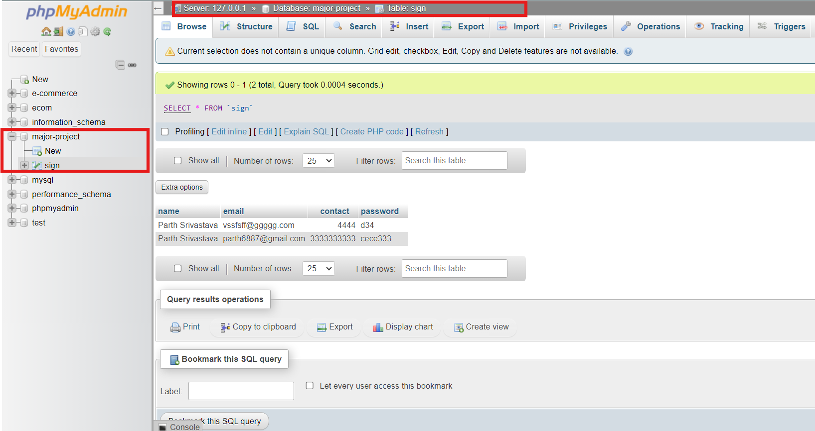

Screen Shot of Website

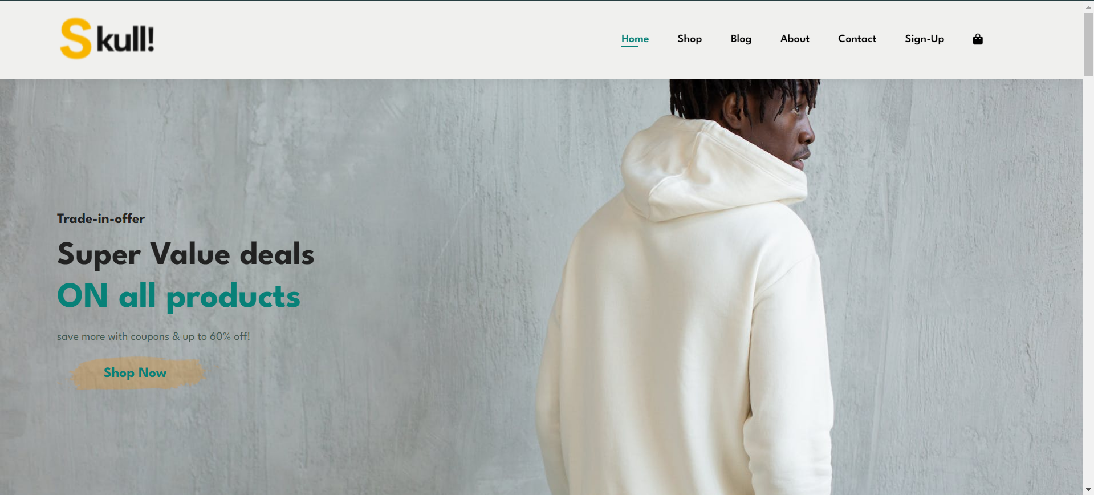

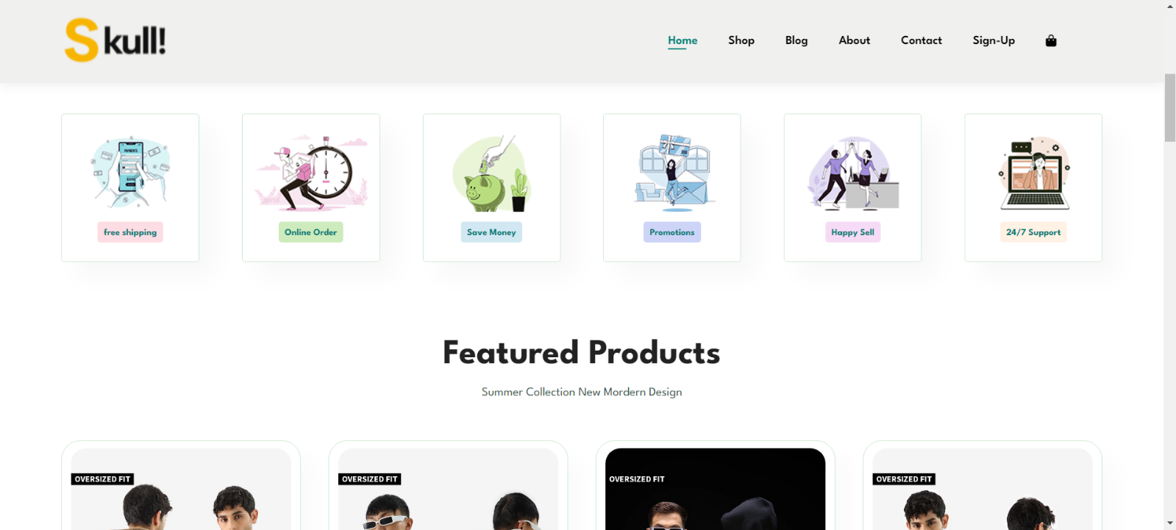

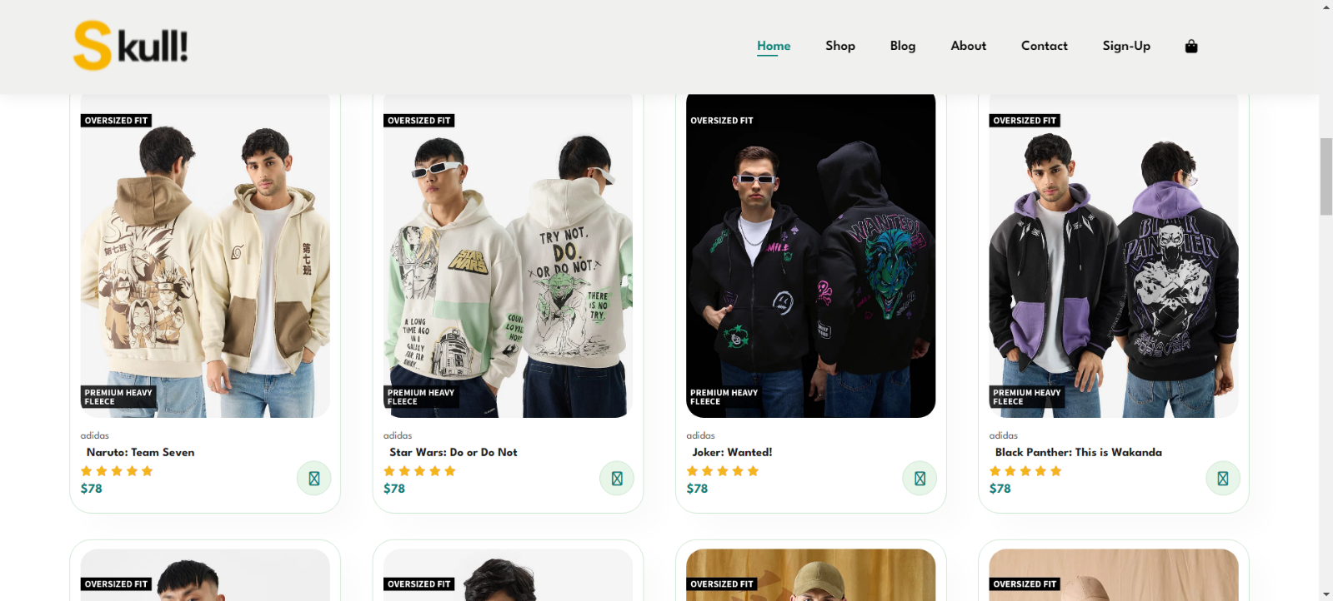

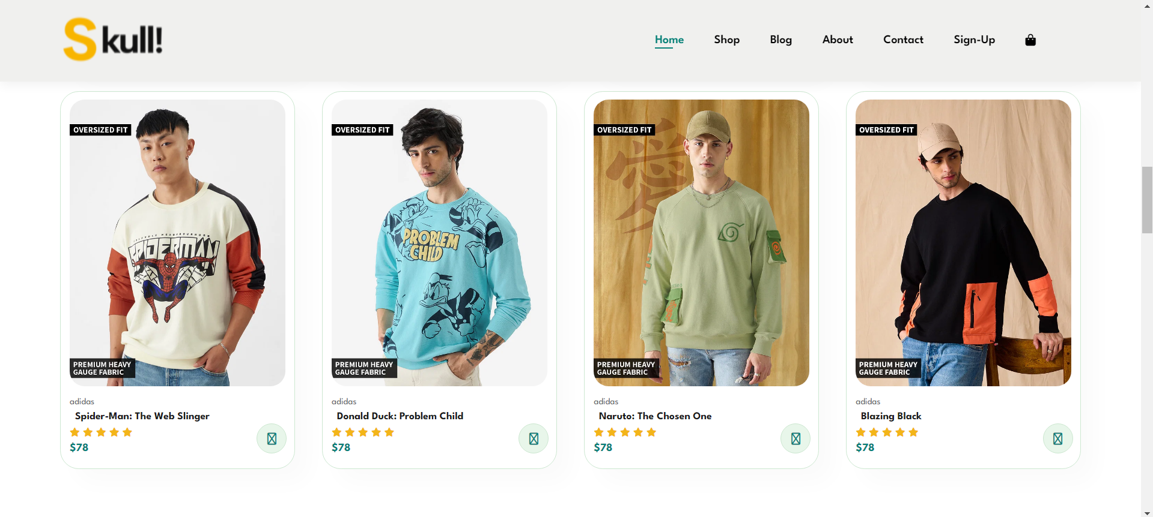

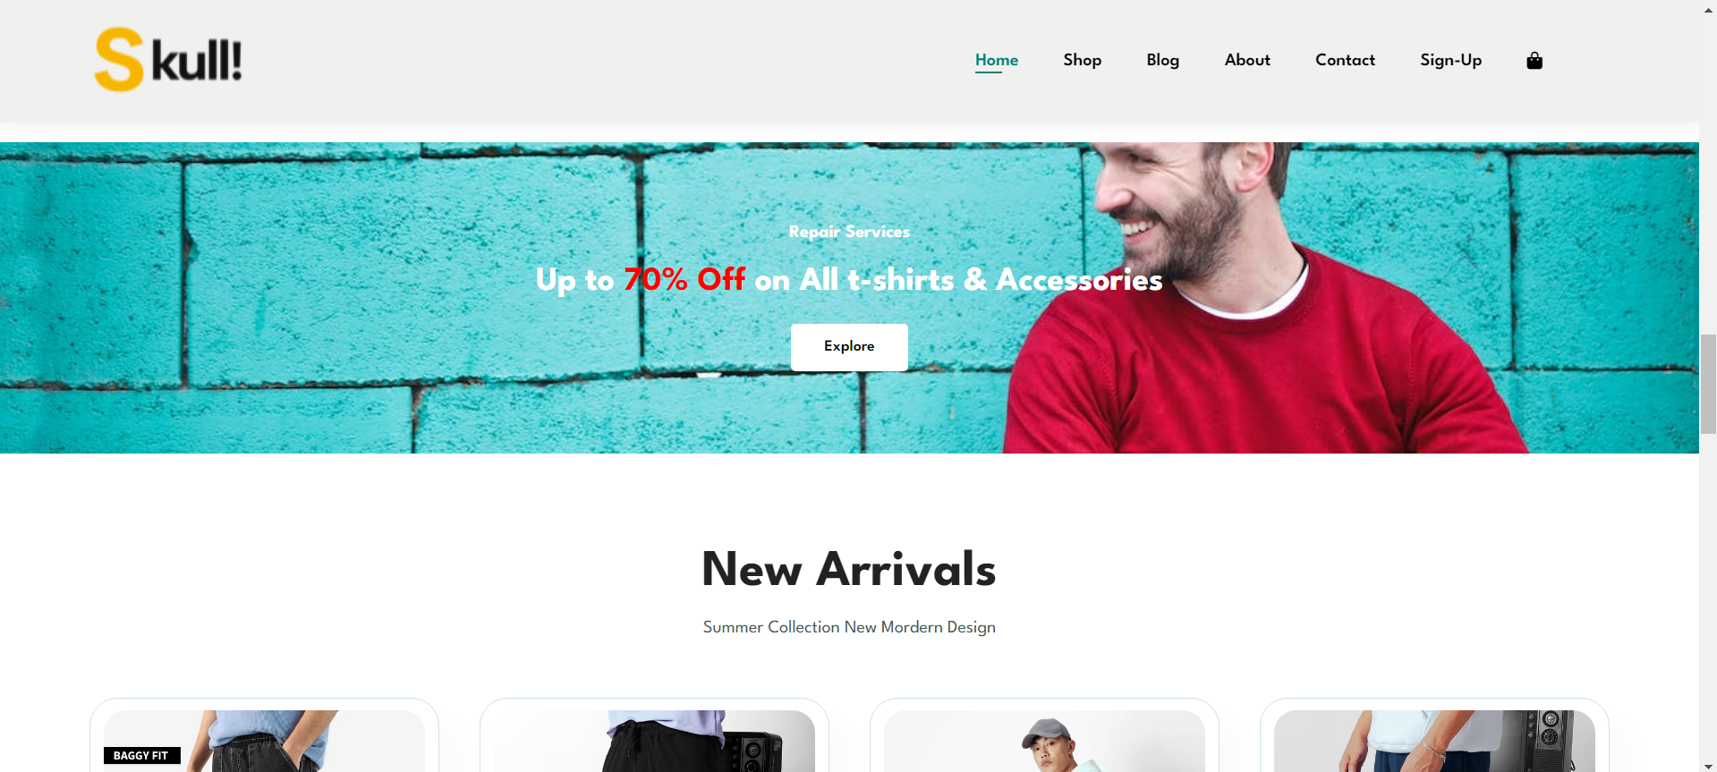

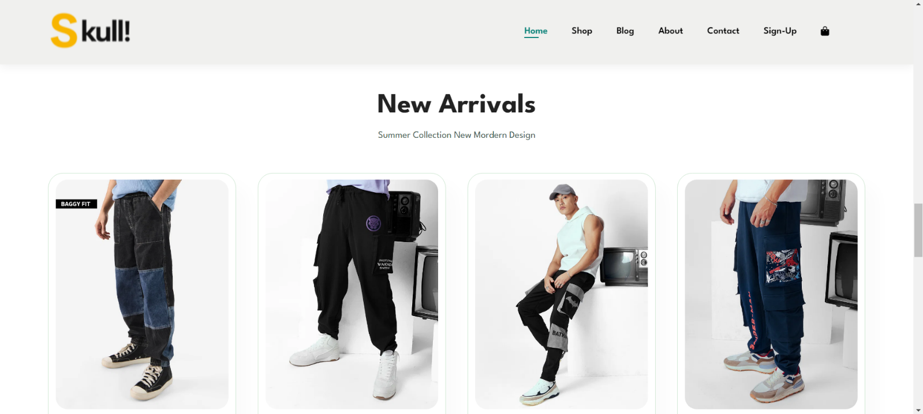

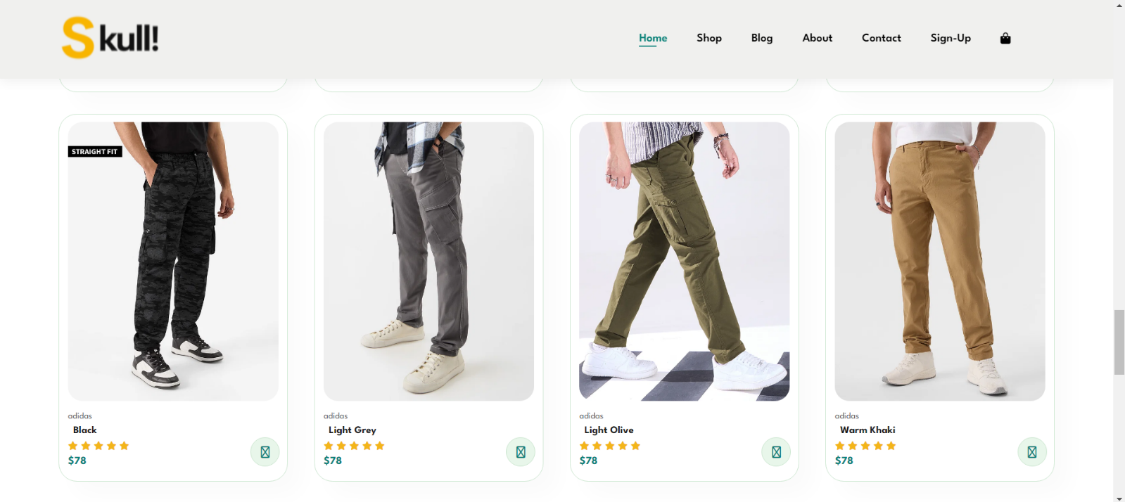

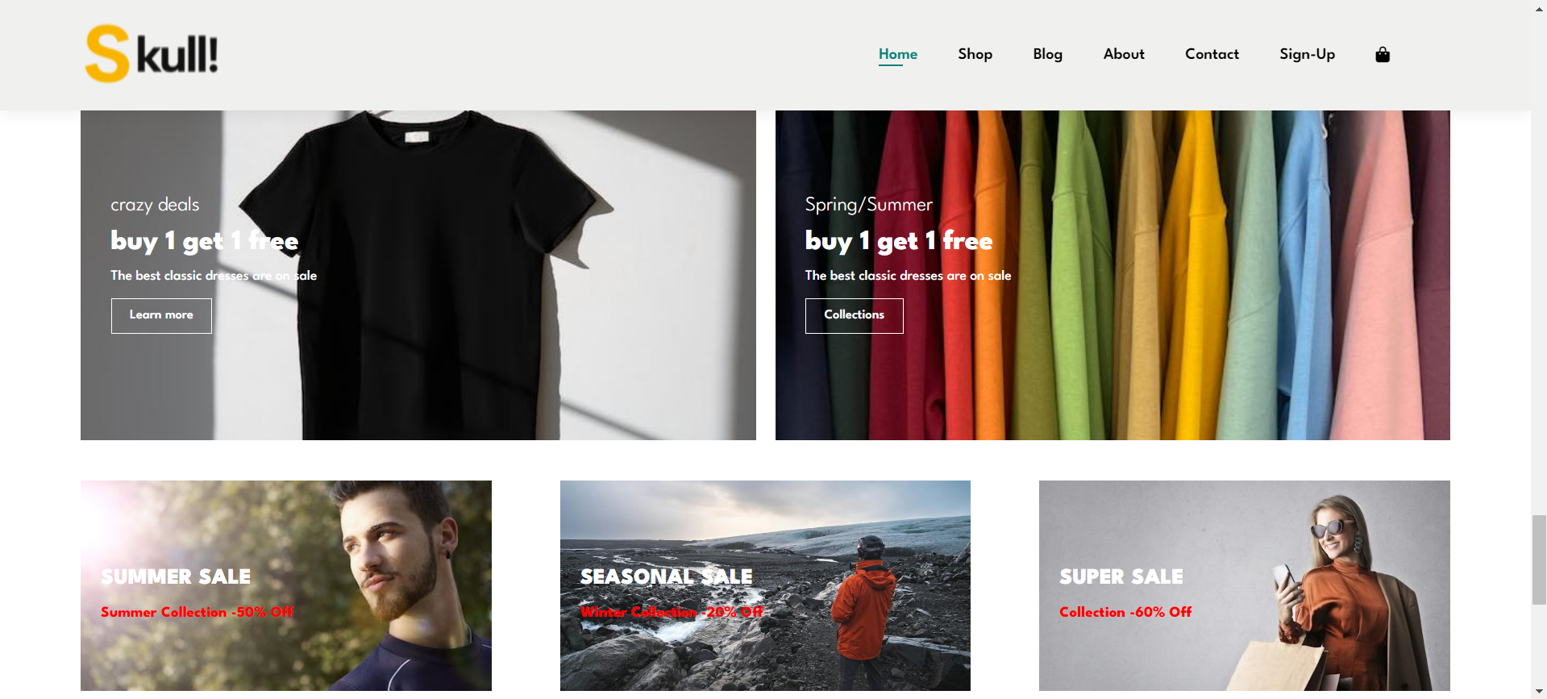

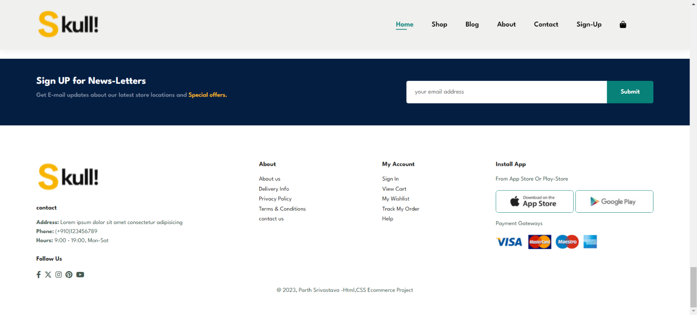

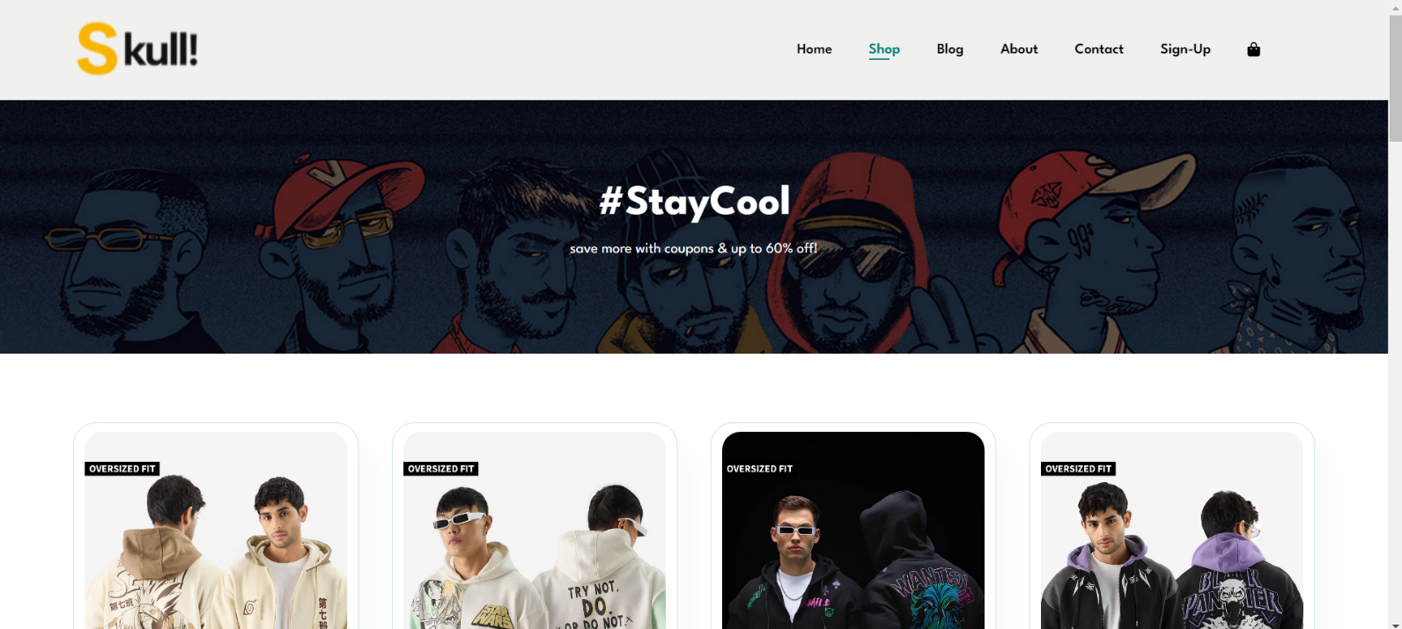

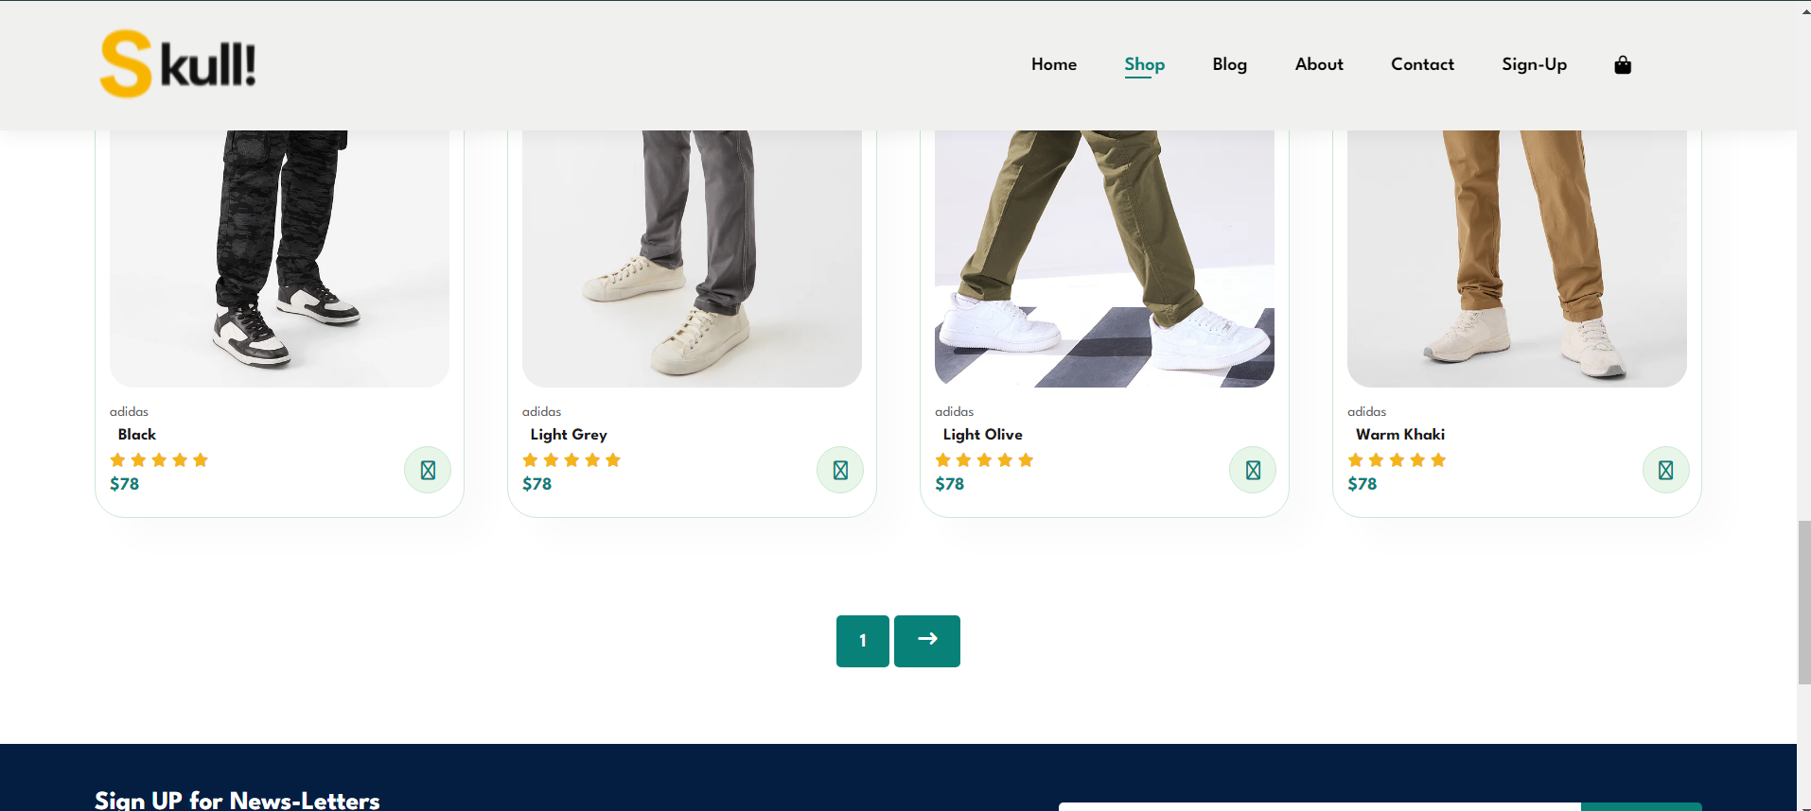

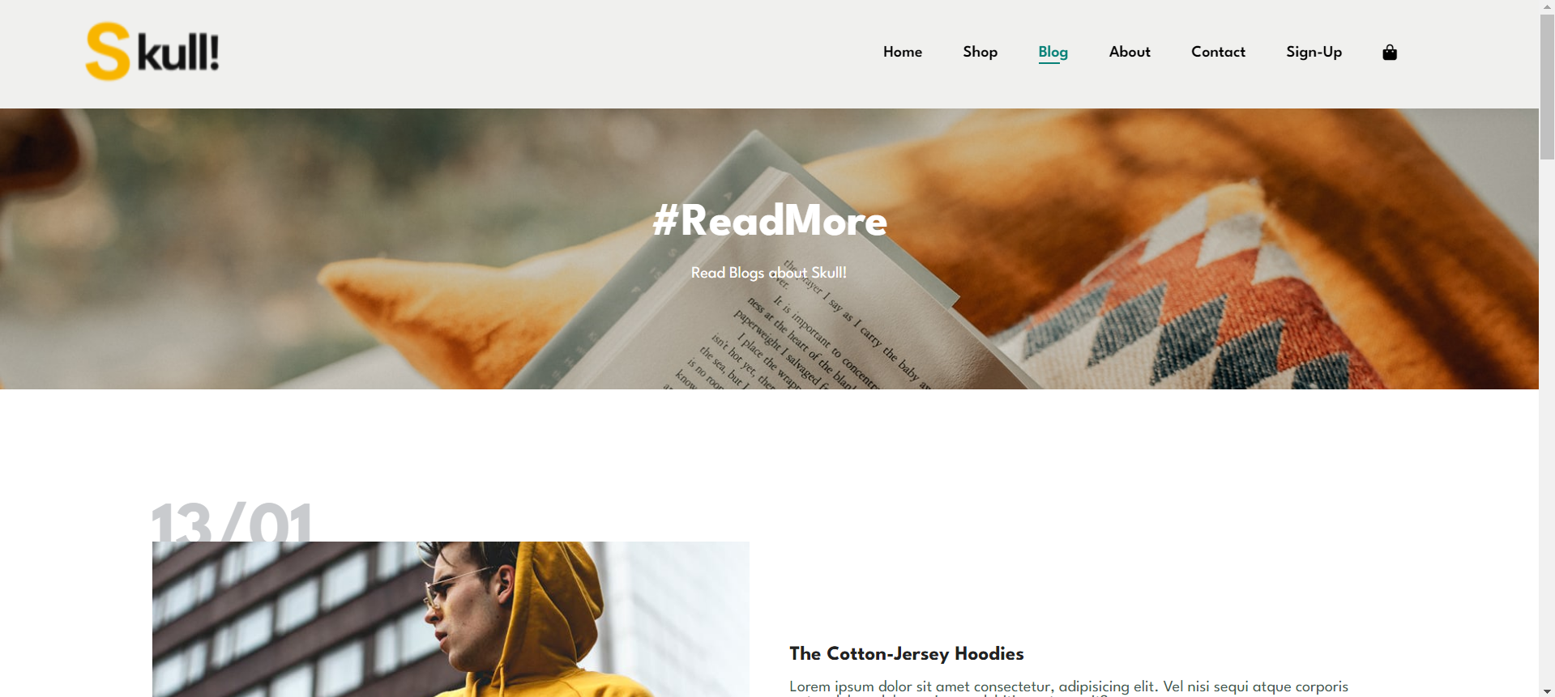

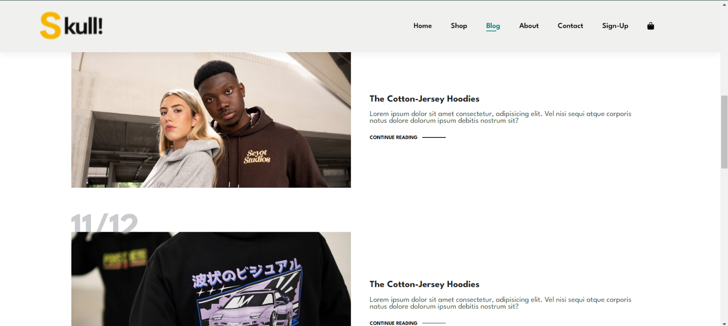

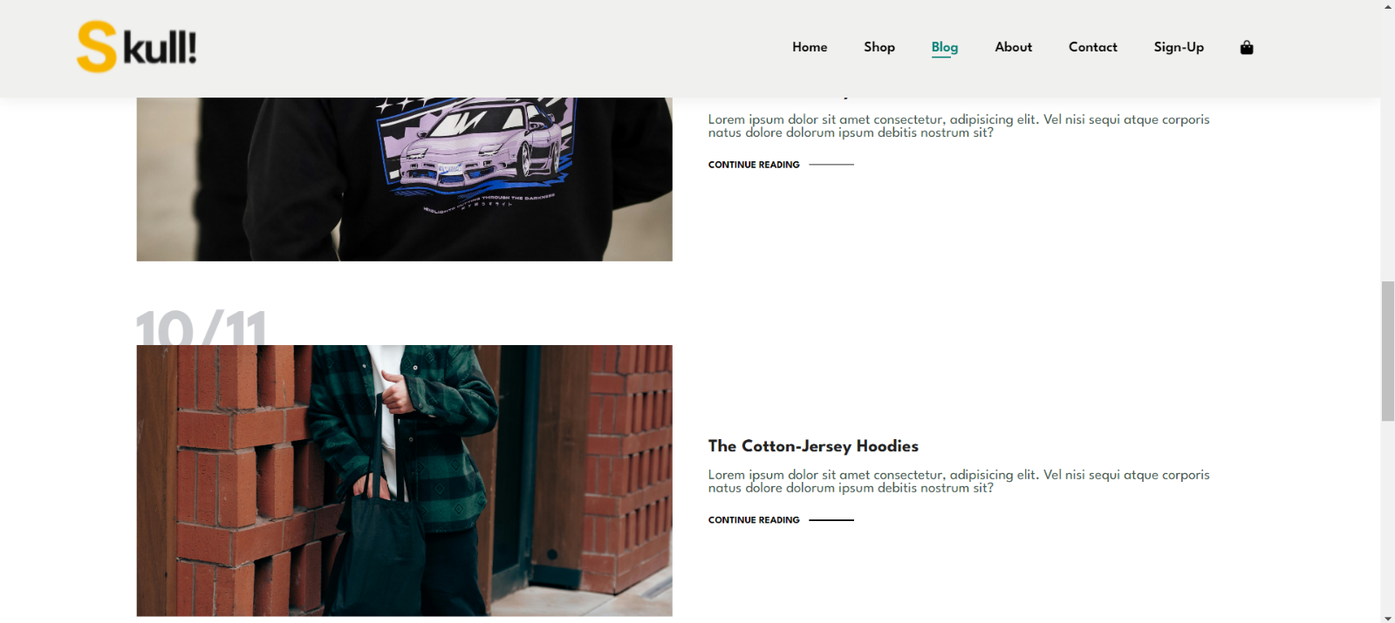

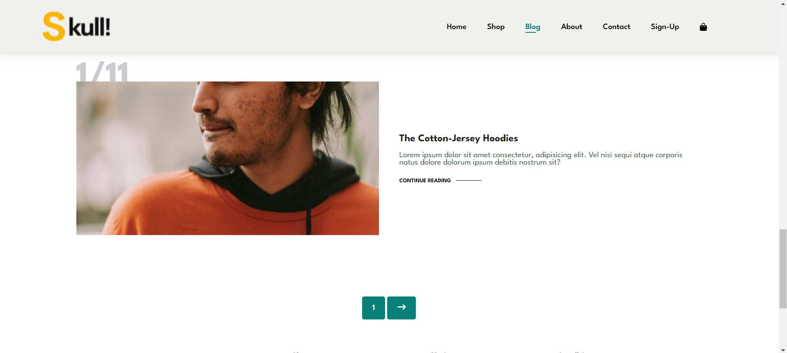

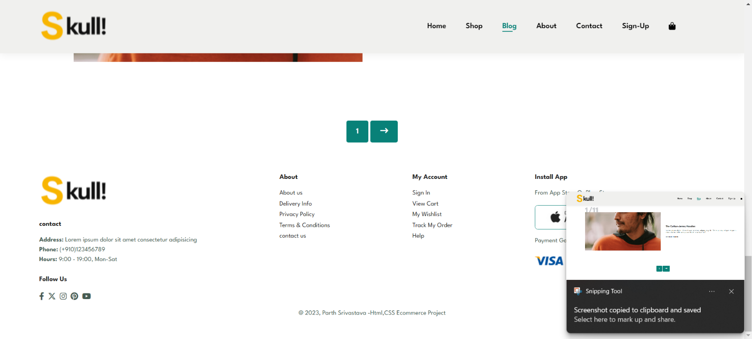

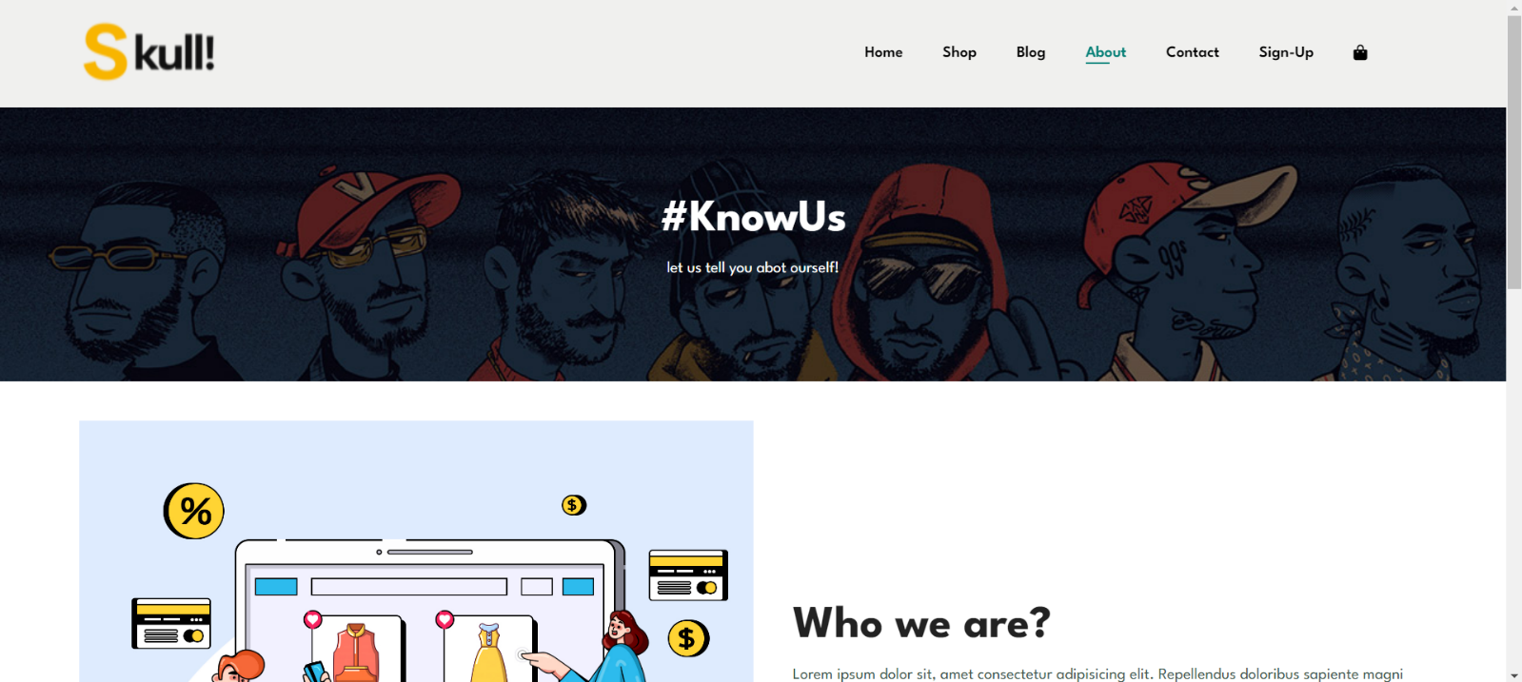

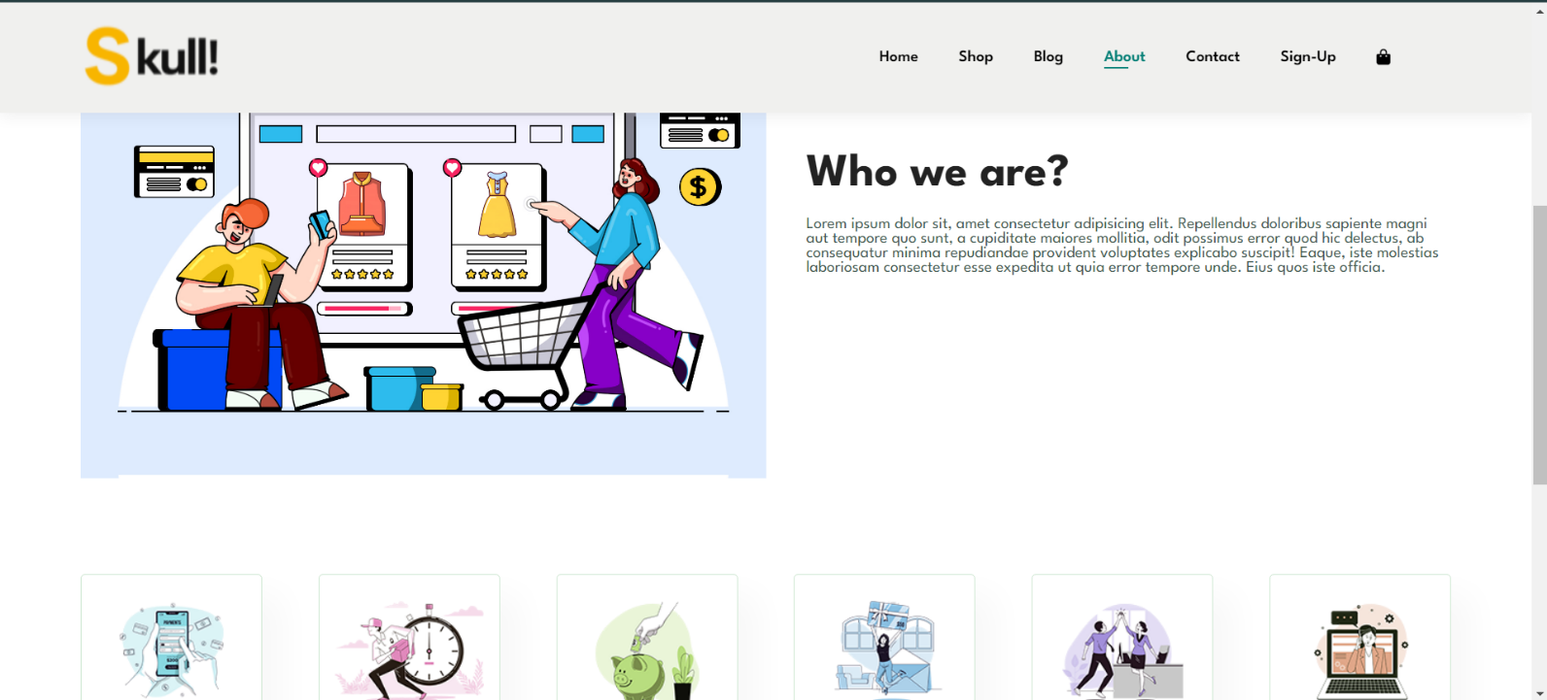

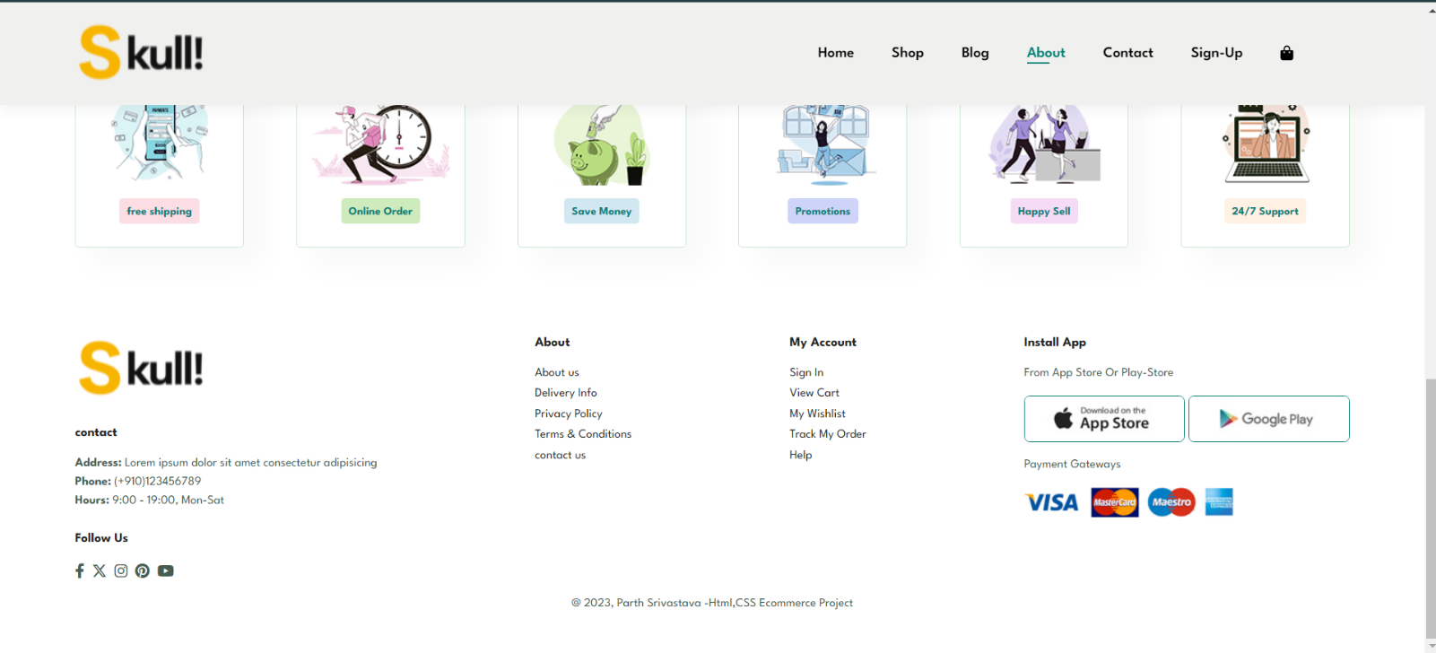

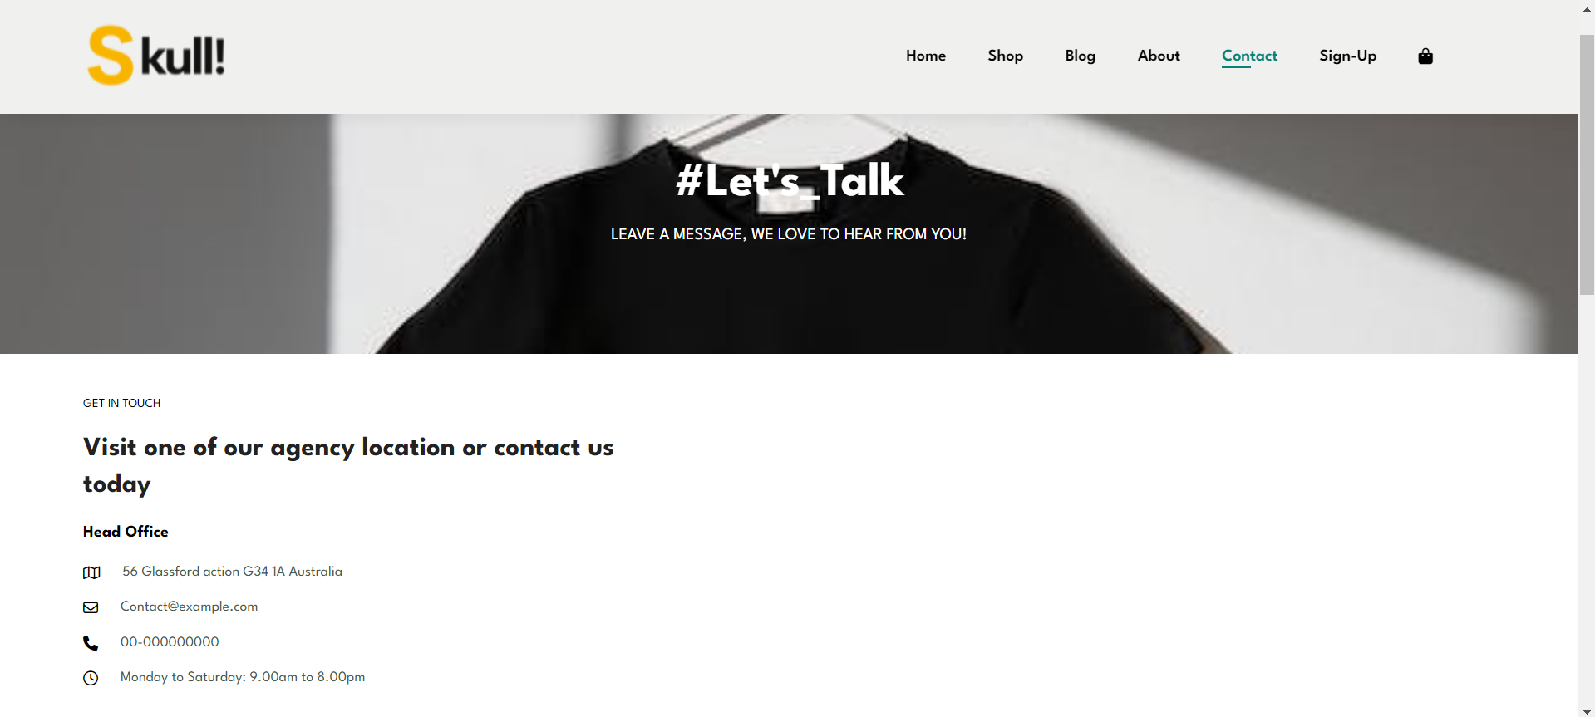

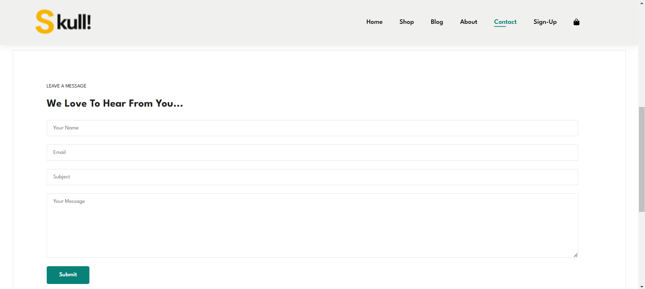

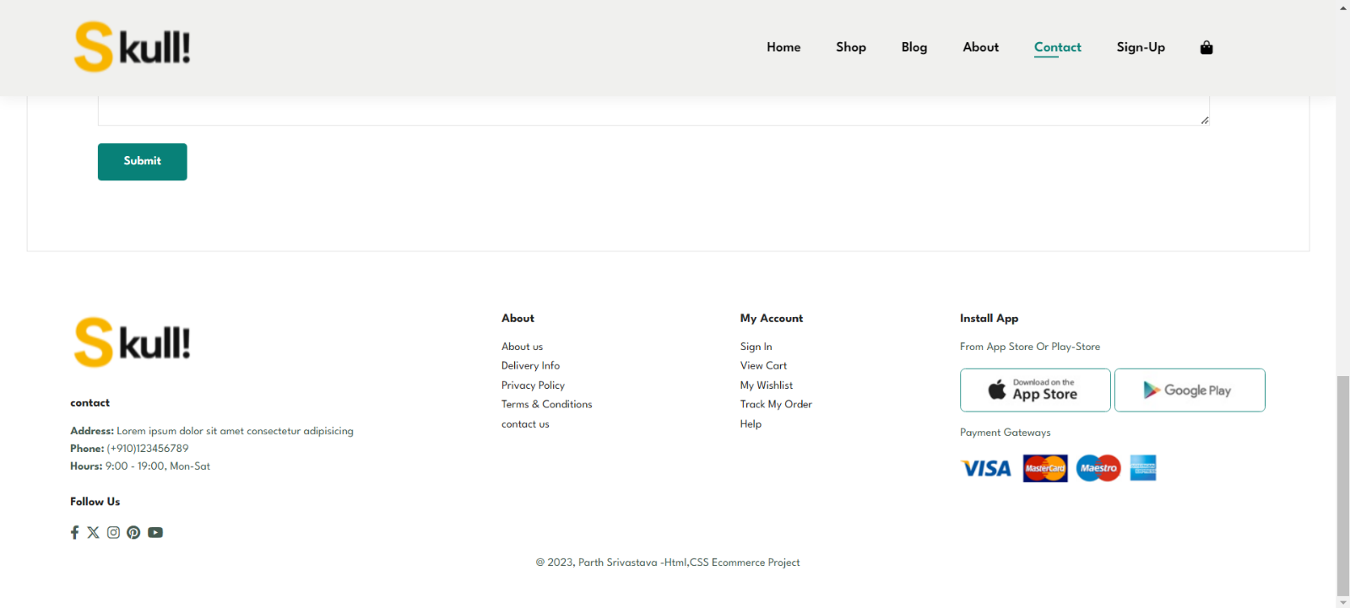

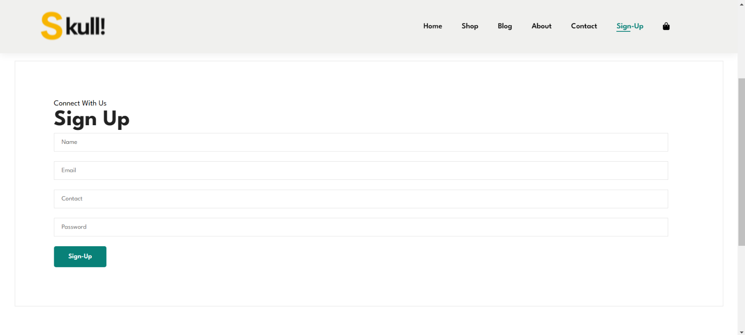

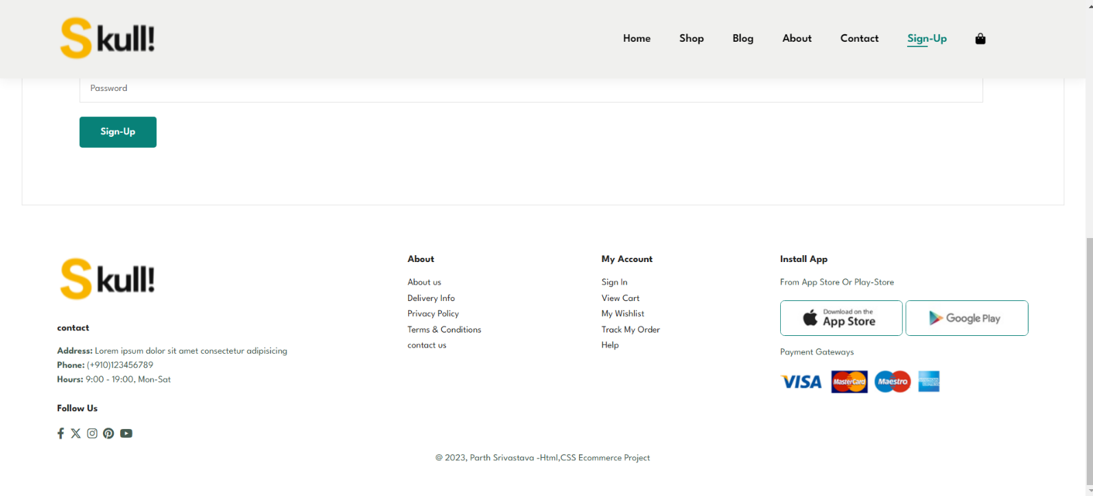

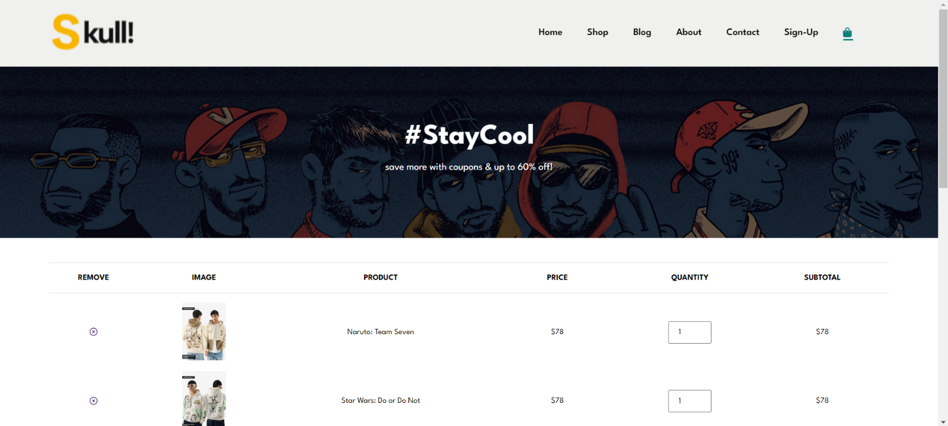

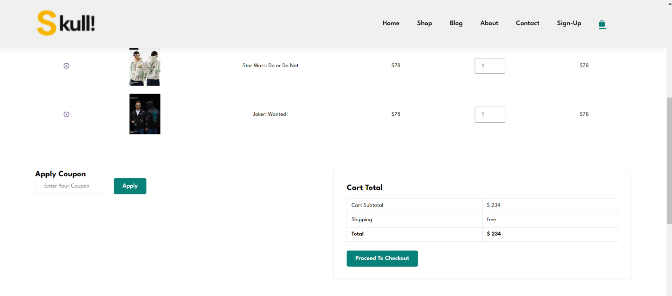

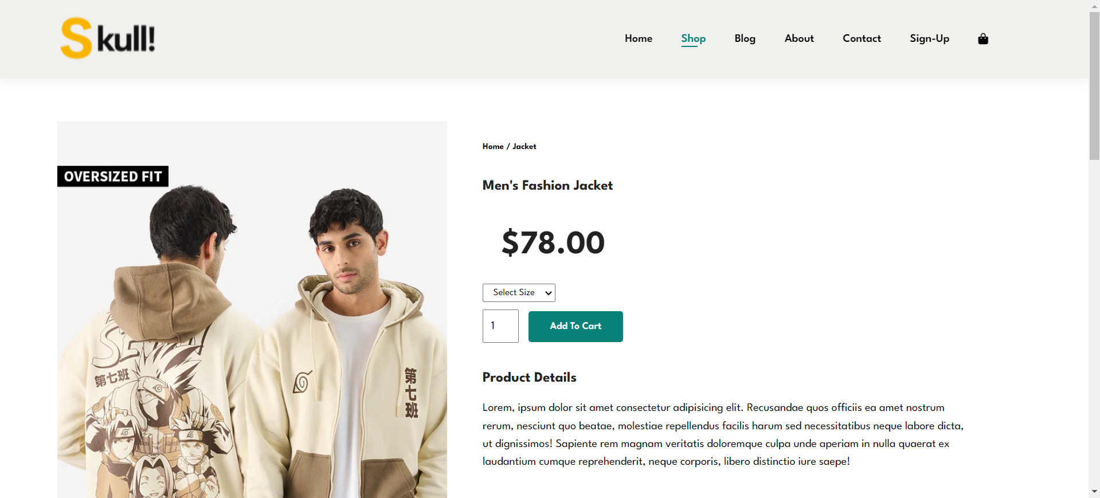

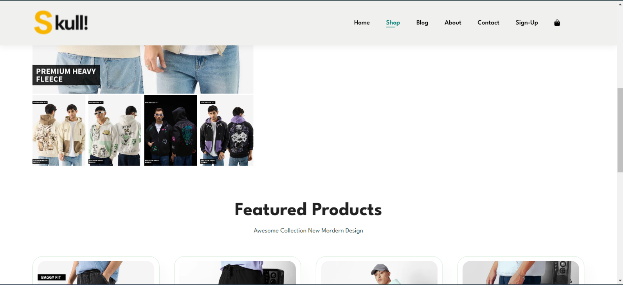

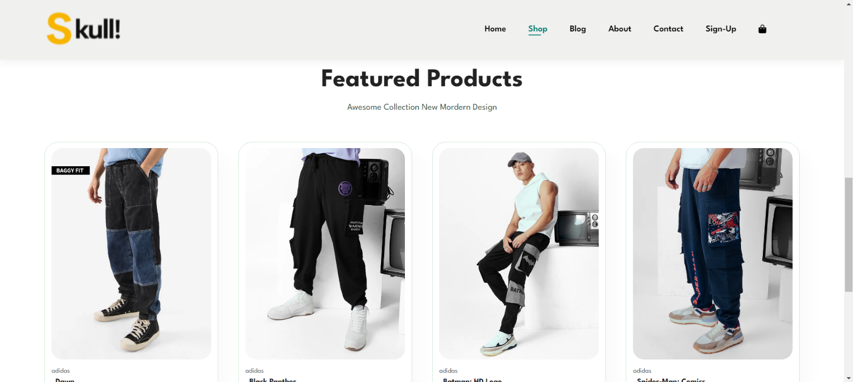

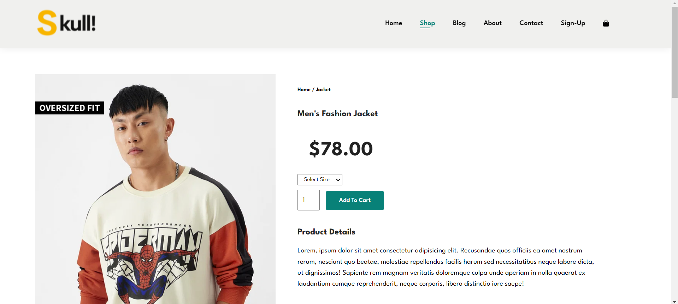

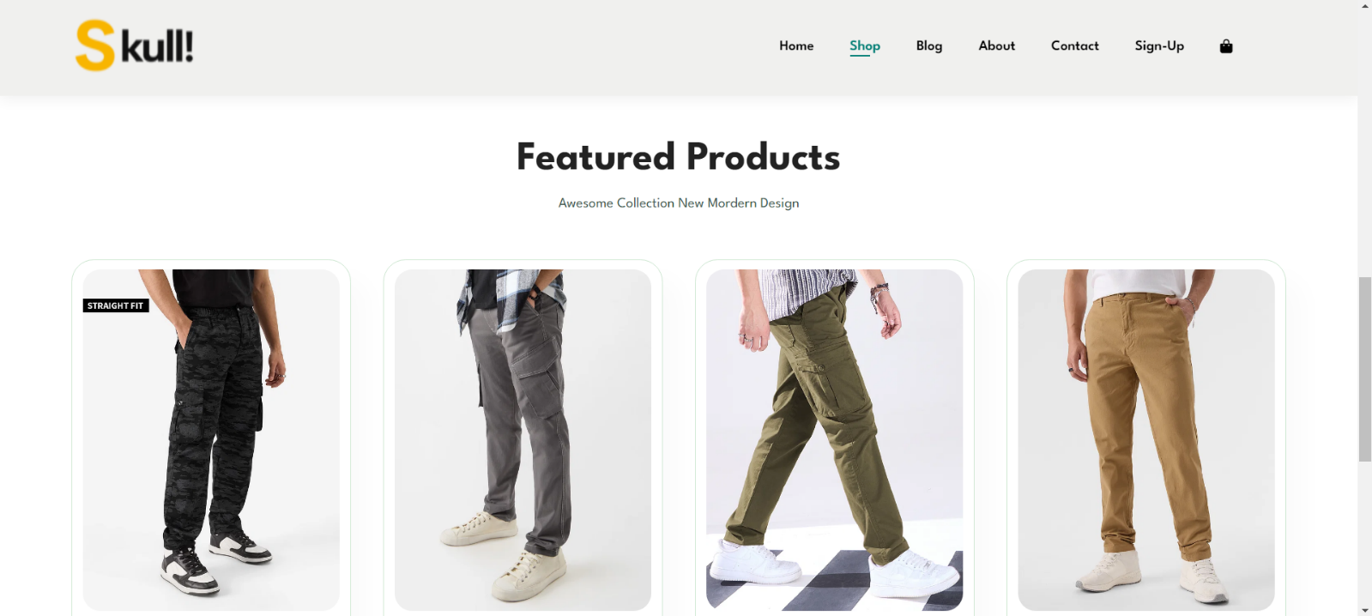

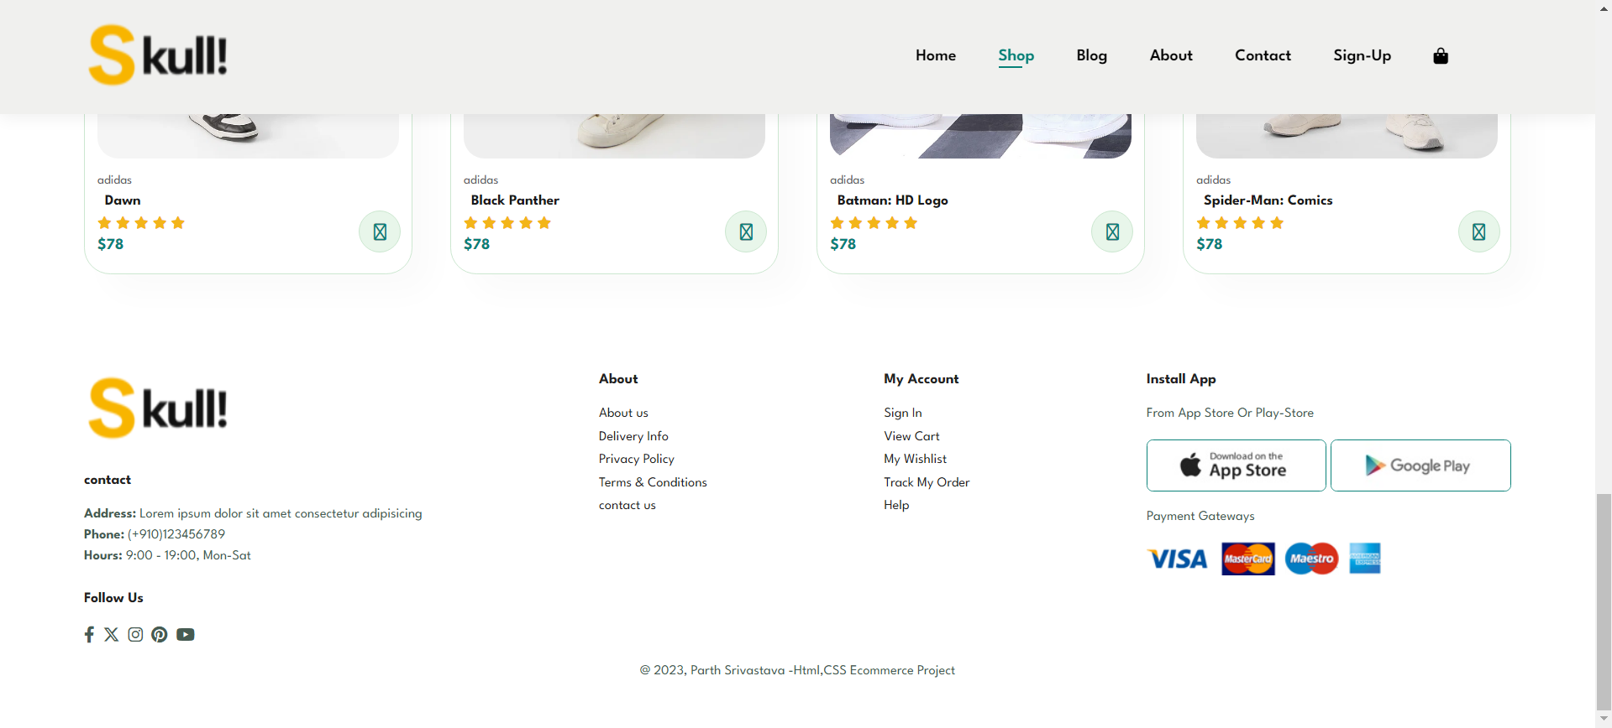

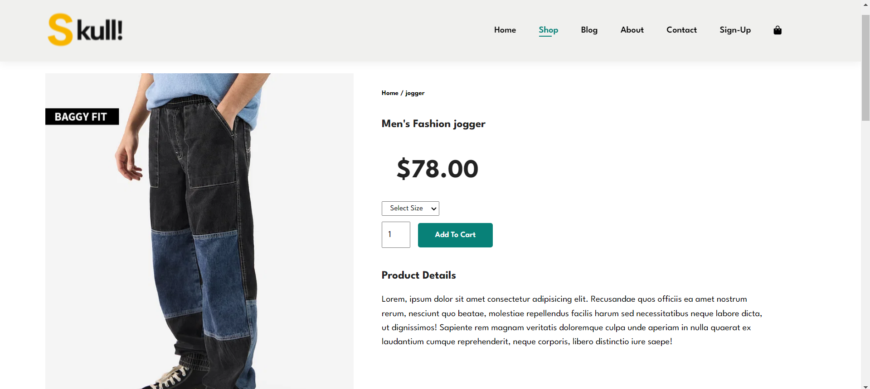

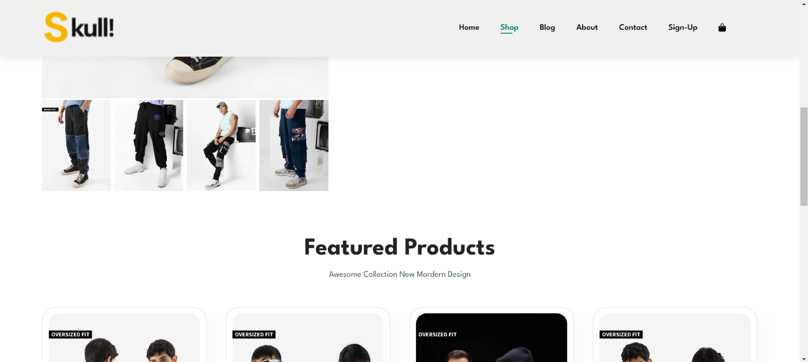

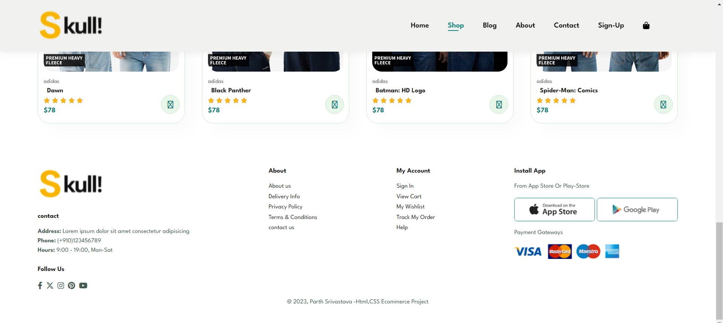

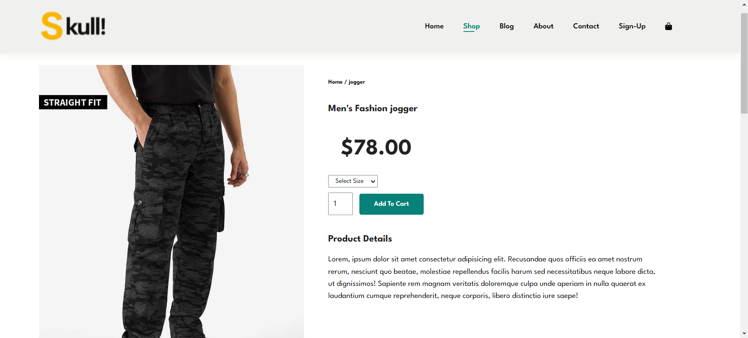

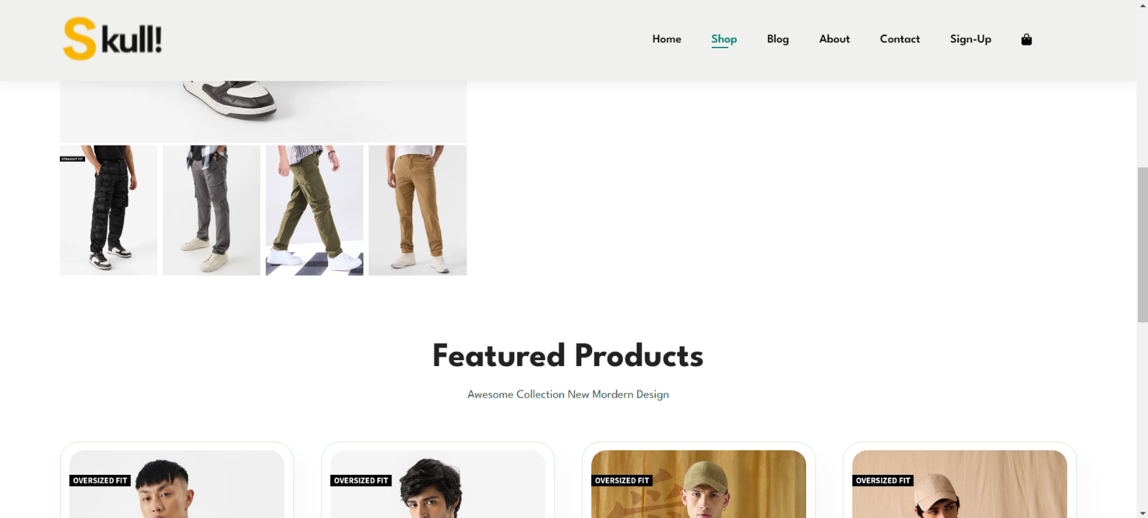

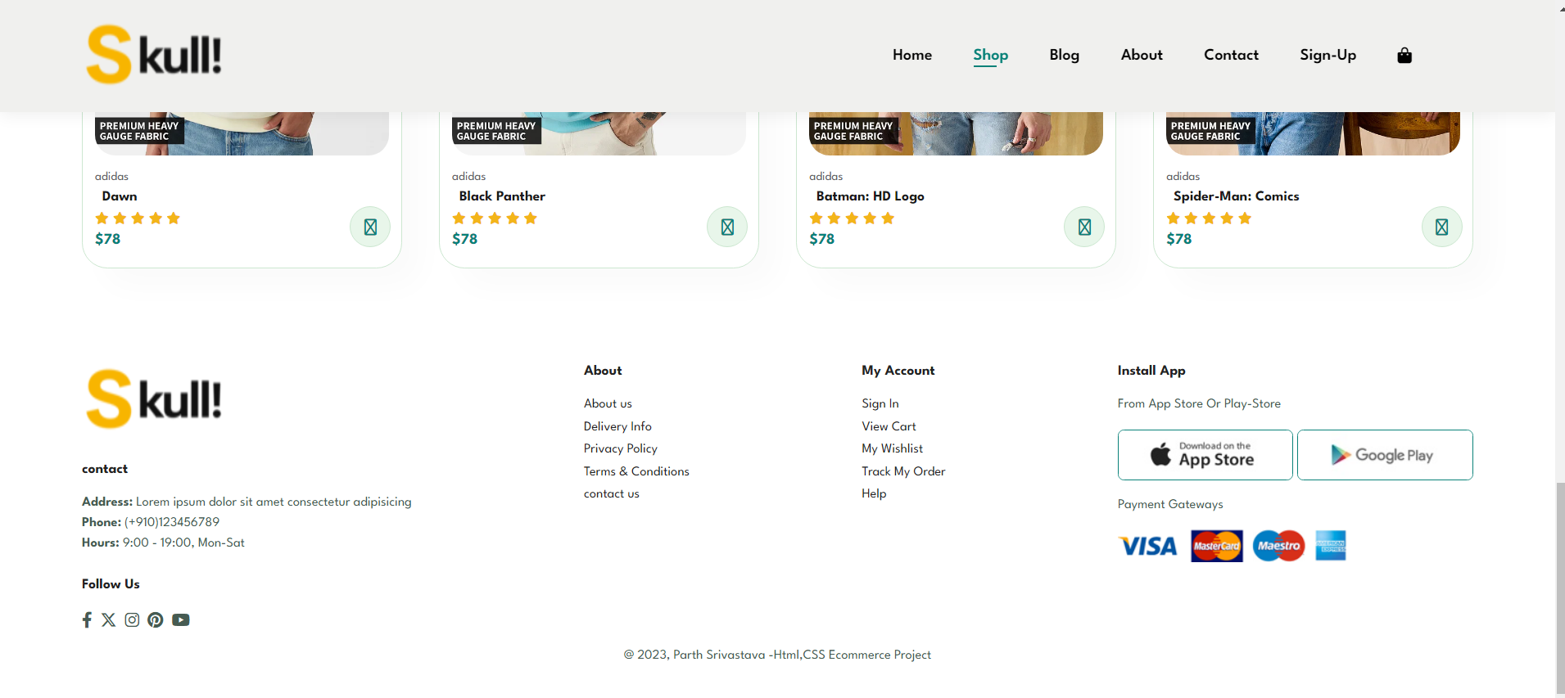

Conclusion

In conclusion, the e-commerce website named Skull offers a userfriendly online platform for purchasing products conveniently. The platform serves as a virtual marketplace, providing customers with access to a diverse range of products displayed on the website. By leveraging the power of e-commerce, Skull eliminates geographical constraints, allowing users to browse and buy items from anywhere with internet access. The project's core objective is to facilitate seamless transactions between buyers and sellers, enhancing the overall shopping experience for users. Through intuitive design and navigation, Skull aims to engage visitors effectively, guiding them through the product selection and purchasing process effortlessly. Key features of the Skull e-commerce website include a visually appealing interface, product categorization

Bibliography

For successfully completing my project on E-commerce website. I have taken help from the following website links ÷

* [www.Youtube.com](http://www.Youtube.com)
* [www.w3schools.com](http://www.w3schools.com)
* [www.wikipedia.com](http://www.wikipedia.com)
* [www.geeksforgeeks.com](http://www.geeksforgeeks.com)
* [www.developer.mozilla.org](http://www.developer.mozilla.org)
* [www.fonts.google.com](http://www.fonts.google.com)
* [www.fontawesome.com](http://www.fontawesome.com)
* [www.apachefriends.org](http://www.apachefriends.org)